

Project Title:

CROPS SUPPLY CHAIN MANAGEMENT SYSTEM - (From

FARMER To MARKET For The CONSUMERS)

Course Title : Database Systems

Course Code: CSE-2201

|  |  |
| --- | --- |
| **Submitted By:**  Name :Md.Khairuzzaman  ID :20221086010  **Semester: 2.2** | **Submitted to:**  Name :Dr. Md. Inzamam - Ul-Hossain  Associate Professor  Department of Computer Science and Engineering  And  Dean  Faculty of Science and Technology  North Western University ,Khulna |

CROPS SUPPLY CHAIN MANAGEMENT SYSTEM

**Description :**

This project aims to develop a comprehensive database system for managing the supply chain of crops, starting from farmers to the market for consumers. The system will streamline the process of crop cultivation, distribution, and sales, ensuring efficiency and transparency throughout the entire supply chain. By integrating various stakeholders and leveraging technology, this database will facilitate better decision-making, reduce wastage, and improve the overall agricultural industry's productivity. Crop supply chain management is a complex system that involves the integrated management of various activities from the production of crops to their delivery to the end consumers. The system encompasses several stages, including seed selection, planting, cultivation, harvesting, processing, storage, transportation, and distribution. Each stage requires careful planning, coordination, and execution to ensure the efficient and effective flow of crops from the farm to the market.

The supply chain management system for crops begins with the identification of market demand and the selection of crops that are in demand. This is followed by the procurement of seeds and other inputs required for cultivation. The cultivation process involves several activities, including soil preparation, planting, irrigation, and pest control. Once the crops are ready for harvest, they are collected and processed, which may involve sorting, grading, packaging, and storage.

The storage of crops is a critical stage in the supply chain management system, as it ensures that there is a continuous supply of crops to the market, even during periods of low production. Transportation and distribution are also crucial stages, as they ensure that the crops are delivered to the market in good condition and at the right time.

The crop supply chain management system is characterized by several challenges, including weather variability, pests and diseases, and market volatility. To address these challenges, supply chain managers use advanced technologies, such as precision agriculture, blockchain, and artificial intelligence, to improve the efficiency and effectiveness of the supply chain.

In conclusion, crop supply chain management is a critical system that ensures the efficient and effective flow of crops from the farm to the market. It involves several stages, including production, processing, storage, transportation, and distribution, and requires careful planning, coordination, and execution to ensure that crops are delivered to the market in good condition and at the right time.

Introduction :

Background of the agricultural industry and the importance of efficient supply chain management.Overview of the project goals and objectives.

# System Architecture

Description of the proposed database system's architecture, including its components and interactions.

Explanation of how different stakeholders (farmers, distributors, retailers, consumers) will interact with the system.

Overview of the technology stack to be used for development.

# Database Design

Entity-relationship diagram (ERD) illustrating the database schema. Description of each entity, its attributes, and relationships with other entities.Justification for the chosen database design and normalization process.

# Functional Requirements

Detailed description of the system's functionalities, including:

Farmer management: registration, profile management, crop cultivation data entry.Inventory management: tracking crop inventory, storage, and quality control.Distribution management: logistics planning, transportation tracking.Market management: pricing, promotions, sales tracking. Consumer interface: online marketplace, product information, order placement.Use case diagrams and scenarios to illustrate how different stakeholders interact with the system.

# Non-Functional Requirements

Performance requirements: system scalability, response time, and throughput.Security requirements: user authentication, data encryption, access control.Usability requirements: intuitive user interface, accessibility features.Reliability requirements: system availability, fault tolerance, disaster recovery.

# Literature Review

Previous research and studies related to crop supply chain management systems.Analysis of existing database systems used in agricultural supply chains.Identification of challenges and opportunities in crop supply chain management.

# Implementation

Overview of the development process, including methodologies and tools used.Description of key features implemented and challenges faced during development.Testing methodologies employed to ensure the system's functionality and reliability.

# Conclusion

Summary of the project objectives and achievements.Discussion of the potential impact of the developed database system on the agricultural industry.Suggestions for future enhancements and research directions,References . List of cited sources and relevant literature used in the project.This structure provides a comprehensive overview of the project, covering all essential aspects of the crops supply chain management system from farmers to market for consumers.

**User Tables (Detailed Description) :**

Admin : This Admin table will store information about the administrators or employees responsible for managing the system. Each admin will have a unique ID number, their name, and their address recorded in the table.

Farmers: Farmers are the primary producers of crops. They provide information about the crops they have available for sale, including quantity and price per unit.

Suppliers: Suppliers procure crops from farmers and supply them to distributors or sellers. They maintain information about available crops, quantities, and prices.

Distributors: Distributors receive crops from suppliers and manage the distribution process. They record details of received crops, including types, quantities, and dates.

Sellers: Sellers are entities responsible for selling crops to consumers directly or through retail outlets. They provide information about available crops for sale, quantities, and prices.

Consumers: Consumers are the end-users who purchase crops from sellers. They maintain records of their purchases, including types of crops, quantities, total cost, and purchase dates.

**Admin:**

**Attributes:**

ID_No: Unique identifier

Employee_Name: Name of the employee incharge

Address: Address of the admin

Contact_No: Cell phone number of the admin

Email_Address: Email address of the admin

**Farmers Table:**

**Attributes:**

Farmer_ID: Unique identifier for each farmer.

Farmer_Name: Name of the farmer.

Age:Number of years.

Gender:Name of gender.

Contact_Info: Contact information of the farmer. Crop_Type: Type of crops grown by the farmer.

**Supply Table:**

**Attributes:**

Supplier_ID: Unique identifier for each supplier.

Supplier_Name: Name of the supplier.

Contact_Info: Contact information of the supplier.

Location: Location/address of the supplier.

Available_Crops: Types of crops available for supply.

Quantity_Available: Quantity of each crop available for supply.

Price_Per_Unit: Price per unit of each crop.

**Distributor Table:**

**Attributes:**

Distributor_ID: Unique identifier for each distributor. Distributor_Name: Name of the distributor.

Contact_Info: Contact information of the distributor.

Location: Location/address of the distributor.

Crops_Received: Types of crops received from suppliers.

Quantity_Received: Quantity of each crop received. Date_Received: Date of receiving crops.

**Shop Table:**

**Attributes:**

Shop_ID: Unique identifier for each seller.

Shop_Name: Name of the seller.

Shop_Location: Location/address of the seller.

Product_id: Unique identifier for each product.

**Consumers Table:**

**Attributes:**

Consumer_ID: Unique identifier for each consumer.

Consumer_Name: Name of the consumer.

Contact_Info: Contact information of the consumer.

Location: Location/address of the consumer.

Crops_Purchased: Types of crops purchased.

Quantity_Purchased: Quantity of each crop purchased.

Total_Cost: Total cost of purchase.

Purchase_Date: Date of purchase.

**Database Tables Description with Entity Relations**

**Explanation**

**Admin Table(Primary key: ID_No)**

* Primary key: ID_No
* Attributes: ID_No, Employee_Name, Contact_No, Email_Address

**Crop Demand in Market Table (Primary Key: Crop_ID, Foreign Key:**

# ID_NO)

* Primary Key: Crop_ID
* Foreign Key: ID_No (References to Admin Table)
* Attributes: Crop_ID,ID_No, Market_Demand, Price_Per_Unit

# Farmer Table (Primary Key: Farmer_ID,Foreign key:ID_No)

* Primary Key: Farmer_ID ● Foreign Key: ID_No,Crop_ID.
* Attributes: Farmer_ID,Crop_ID, Farmer_Name, Age, Gender, Farmer_Contact_Number

# Property Table (Primary Key: Property_ID, Foreign Key: Farmer_ID)

* Primary Key: Property_ID
* Foreign Key: Farmer_ID (References to Farmer Table)
* Attributes: Property_ID, Farmer_ID, Property_Address,

Property_Size, Property_Value,Crop_Type

# Farmers Cost Table (Primary Key: Cost_ID, Foreign Key: Farmer_ID)

* Primary Key: Cost_ID
* Foreign Key: ID_No(References to Admin Table),Farmer_ID (References to Farmer Table)
* Attributes: Cost_ID, ID_No, Farmer_ID, Seed_Cost, Fertilizer_Cost,

Labor_Cost, Other_Expenses

**Harvesting Equipment System Table (Primary Key: Equipment_ID,**

# Foreign key:ID_No)

* Primary Key: Equipment_ID
* Foreign Key: ID_No(References to Admin Table)
* Attributes: Equipment_ID,ID_No, Equipment_Name,

Equipment_Type, Equipment_Cost

# Crop Batch Table (Primary Key: Batch_ID, Foreign Key: Crop_ID, Farmer_ID, ID_No)

* Primary Key: Batch_ID
* Foreign Keys: Crop_ID(References to Crop Demand in Market Table), Farmer_ID (References to Farmer Table),ID_No (References to Admin Table)
* Attributes: Batch_No, Crop_ID, Farmer_ID, Batch_Size,

Batch_Rate,Batch_Date

# Farmers Profit Table (Primary Key: Profit_ID, Foreign Key: Farmer_ID)

* Primary Key: Profit_ID
* Foreign Key: Farmer_ID (References to Farmer Table),
* Attributes: Profit_ID, Farmer_ID, Total_Revenue, Total_Expenses, Net_Profit

**Farmers Loan Table (Primary Key: Loan_ID, Foreign Key:**

# Farmer_ID,Cost_ID)

* Primary Key: Loan_ID
* Foreign Key: Farmer_ID(References to Farmer

Table),Cost_ID(References to Farmers Cost Table),

ID_No(References to Admin Table)

* Attributes: Loan_ID, Farmer_ID,Cost_ID, Loan_Amount,

Interest_Rate, Loan_Duration,ID_No

# Product Supply Table (Primary Key: Supply_ID,Foreign Key: Crop_ID, ID_No)

* Primary Key: Supply_ID
* Foreign Key: Crop_ID(References to Crop Demand in Market Table),ID_No (References to Admin Table)
* Attributes: Supply_ID,Crop_ID,ID_No, Supply_Quantity, Supply_Date

**Supply Management Table (Primary Key: Supplier_ID, Foreign Key:**

# Supply_ID,Batch_ID)

* Primary Key: Supplier_ID
* Foreign Key: Supply_ID(References to Product Supply

Table),Batch_ID(References to Crop Batch Table),ID_No(References to Admin Table)

* Attributes:,Supplier_ID,Supplier_Name,Supply_ID,Management_Typ e,Batch_ID,ID_No

# Manufacturer Table(Primary Key: Product_ID,Foreign key: Supply_ID, ID_No)

* Primary Key: Product_ID
* Foreign Key: Supply_ID(References to Supply

Table),ID_No(References to Admin Table)

* Attributes:Product_ID,Product_Name,Product_Price,No_of_Package s,Supply_ID,ID_No

**Distribution Center Table (Primary Key: Center_ID,Foreign key:**

# Product_ID, ID_No)

* Primary Key: DCenter_ID
* Foreign Key: Product_ID(References to Manufacturer Table), ID_No (References to Admin Table)
* Attributes: DCenter_ID,Product_ID,ID_No Center_Name,

Center_Location

**Shops/Seller/Market Table (Primary Key: Shop_ID ; Foreign Key:**

# Product_ID, Tax_ID , DCenter_ID)

* Primary Key: Shop_ID
* Foreign Key : Product_ID(References to Manufacturer Table) ,

Tax_ID (References to Tax Table),DCenter_ID (References to

Distribution Center Table)

* Attributes: Shop_ID, Product_ID,Tax_ID,DCenter_ID,Shop_Name, Shop_Location

**Exportation Table (Primary Key: Shipment_ID, Foreign Key:**

# Crop_ID,Tax_ID,Supplier_ID)

* Primary Key: Shipment_ID
* Foreign Key: Crop_ID (References to Crop Demand in Market

Table),Tax_ID (References to Tax Table),Supplier_ID (References to Supply Management Table)

* Attributes:Shipment_ID, Crop_ID,Tax_ID,Supplier_ID,Shipment_Cost, Export_Quantity, Export_Date

# Tax Table (Primary Key: Tax_ID , Foreign Key: ID_No)

* Primary Key: Tax_ID
* Foreign Key: ID_No( References to Admin Table)
* Attributes: Tax_ID, ID_No, Tax_Type, Tax_Rate

**Buyers/Consumer Table (Primary Key: Buyers_ID , Foreign Key :**

# Product_ID, Tax_ID, Shop_ID)

* Primary Key: Buyers_ID
* Foreign Key: Product_ID (References to Manufacture Table),Tax_ID (References to Tax Table) , Shop_ID (References to Seller Table)
* Attributes: Buyers_ID,Product_ID, Tax_ID,Shop_ID, Buyers_Name,

Buyers_Contact

**Total Transaction in Economy Table (Primary Key: Transaction_ID ,**

# Foreign Key: Tax_ID, ID_No)

* Primary Key: Transaction_ID
* Foreign Key: Tax_ID (References to Tax Table),ID_No (References to Admin Table)
* Attributes: Transaction_ID, Tax_ID, ID_No ,Total_Transaction_Value, Transaction_Date

**Entity Relationships:**

* **Admin to Crop Demand in Market:** One-to-Many (One admin can manage multiple crop demands in the market).
* **Admin to Farmer:** One-to-Many (One admin can manage multiple farmers).
* **Admin to Harvesting Equipment System:** One-to-Many (One admin can manage multiple harvesting equipment systems).
* **Admin to Tax:** One-to-Many (One admin can manage multiple tax calculations).
* **Admin to Total Transaction in Economy:** One-to-One (One admin can handle the total transaction).
* **Admin to Product Supply:** One-to-Many (One admin can maintain multiple product supplies).
* F**armer to Farmers Property:** One-to-Many (One farmer can have multiple properties).
* **Farmer to Farmers Cost:** One-to-Many (One farmer can have multiple costs).
* **Farmer to Crop Batch:** One-to-Many (One farmer can have multiple crop batches).
* **Farmer to Farmer Profit:** One-to-One (One farmer has one profit record).
* **Farmer to Farmers Loan:** One-to-Many (One farmer can have multiple loans).
* **Crop Type to Crop Demand in Market:** One-to-One (Each crop type has one market demand).
* **Crop Type to Crop Batch:** One-to-Many (One crop type can have multiple batches).
* **Crop Type to Exportation:** One-to-Many (One crop type can have multiple export records).
* **Crop Type to Production Supply:** One-to-Many (One crop type can have multiple supply records).
* **Production Supply to Supply Management:** One-to-One (One supply has one management record).
* **Production Supply to Supply Management Budget:** One-to-One (One supply has one budget record).
* **Supply Manager to Supply Management:** One-to-Many (One manager can manage multiple supplies).
* **Distribution Center to Shops/Seller/Market:** One-to-Many (One distribution center can supply to multiple shops/markets).
* **Buyers/Consumer to Total Transaction in Economy:** One-to-Many (One buyer can be involved in multiple transactions).
* **Tax to Total Transaction in Economy:** One-to-Many (One tax type can be applied to multiple transactions)

**ER Diagram :**

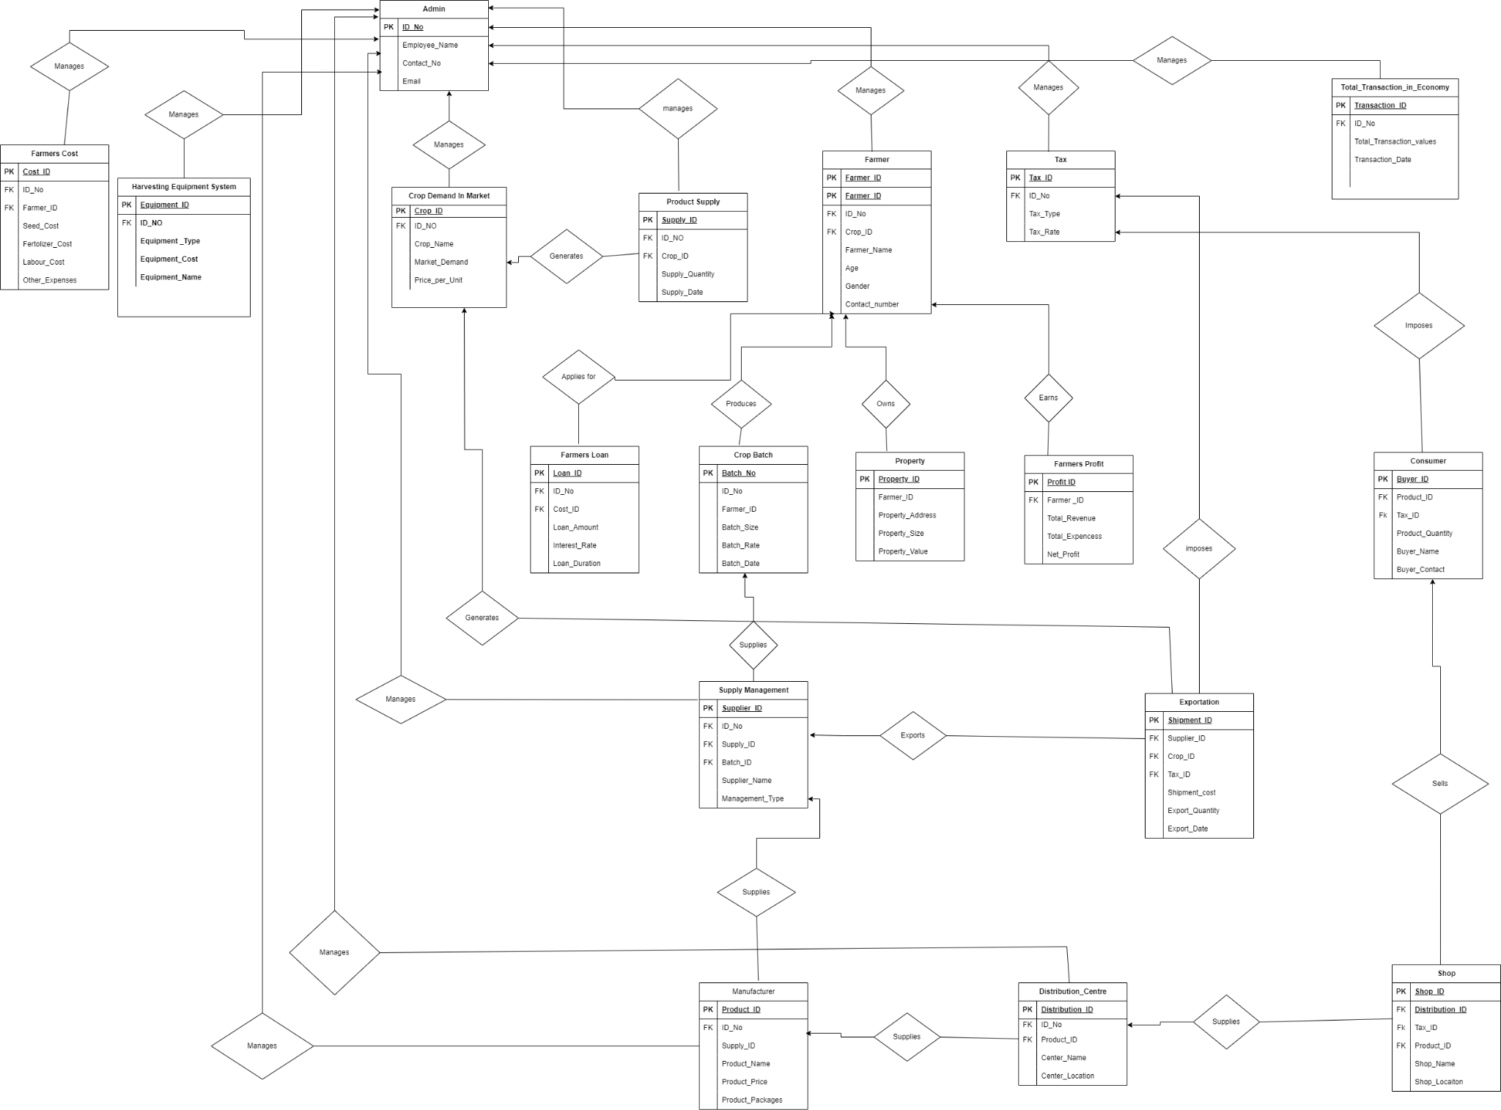

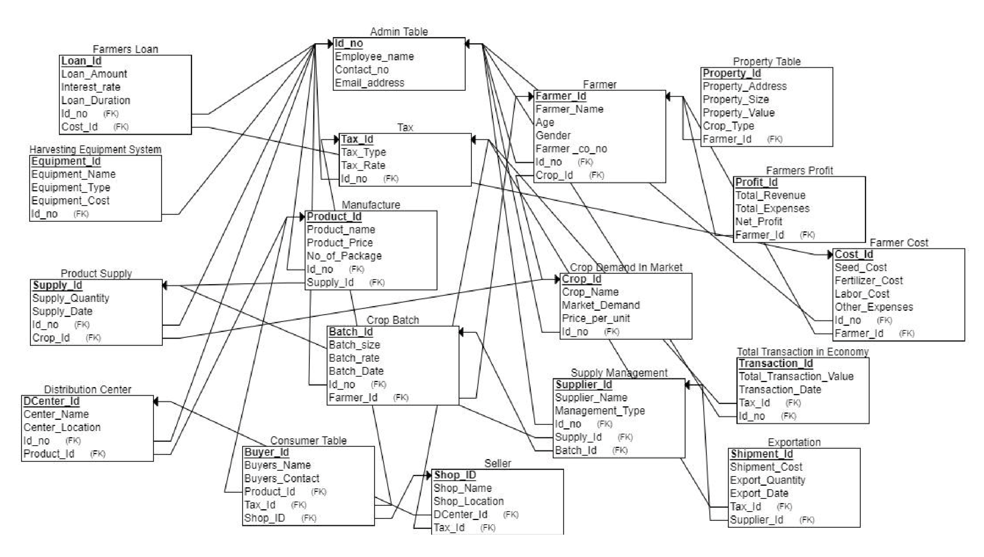**Schema Diagram :**

**Query Part :**

CREATE TABLE Admin (

ID_No INT PRIMARY KEY,

Employee_Name VARCHAR(255),

Contact_No VARCHAR(20),

Email_Address VARCHAR(255)

);

CREATE TABLE Crop_Demand_Market (

Crop_ID INT PRIMARY KEY,

ID_No INT,

Market_Demand INT,

Price_Per_Unit DECIMAL(10, 2),

FOREIGN KEY (ID_No) REFERENCES Admin(ID_No)

);

CREATE TABLE Farmer (

Farmer_ID INT PRIMARY KEY,

ID_No INT,

Crop_ID INT,

Farmer_Name VARCHAR(255),

Age INT,

Gender CHAR(1),

Farmer_Contact_Number VARCHAR(20),

FOREIGN KEY (ID_No) REFERENCES Admin(ID_No),

FOREIGN KEY (Crop_ID) REFERENCES Crop_Demand_Market(Crop_ID)

);

CREATE TABLE Property (

Property_ID INT PRIMARY KEY,

Farmer_ID INT,

Property_Address VARCHAR(255),

Property_Size DECIMAL(10, 2),

Property_Value DECIMAL(15, 2),

Crop_Type VARCHAR(100),

FOREIGN KEY (Farmer_ID) REFERENCES Farmer(Farmer_ID)

);

CREATE TABLE Farmers_Cost (

Cost_ID INT PRIMARY KEY,

ID_No INT,

Farmer_ID INT,

Seed_Cost DECIMAL(10, 2),

Fertilizer_Cost DECIMAL(10, 2),

Labor_Cost DECIMAL(10, 2),

Other_Expenses DECIMAL(10, 2),

FOREIGN KEY (ID_No) REFERENCES Admin(ID_No),

FOREIGN KEY (Farmer_ID) REFERENCES Farmer(Farmer_ID)

);

CREATE TABLE Harvesting_Equipment_System (

Equipment_ID INT PRIMARY KEY,

ID_No INT,

Equipment_Name VARCHAR(255),

Equipment_Type VARCHAR(100),

Equipment_Cost DECIMAL(15, 2),

FOREIGN KEY (ID_No) REFERENCES Admin(ID_No)

);

CREATE TABLE Farmers_Loan (

Loan_ID INT PRIMARY KEY,

Farmer_ID INT,

Cost_ID INT,

Loan_Amount DECIMAL(15, 2),

Interest_Rate DECIMAL(5, 2),

Loan_Duration INT,

ID_No INT,

FOREIGN KEY (Farmer_ID) REFERENCES Farmer(Farmer_ID),

FOREIGN KEY (Cost_ID) REFERENCES Farmers_Cost(Cost_ID),

FOREIGN KEY (ID_No) REFERENCES Admin(ID_No)

);

CREATE TABLE Crop_Batch (

Batch_ID INT PRIMARY KEY,

Crop_ID INT,

Farmer_ID INT,

ID_No INT,

Crop_Name Varchar(50), Batch_Size INT,

Batch_Rate DECIMAL(10, 2),

Batch_Date DATE,

FOREIGN KEY (Crop_ID) REFERENCES Crop_Demand_Market(Crop_ID),

FOREIGN KEY (Farmer_ID) REFERENCES Farmer(Farmer_ID),

FOREIGN KEY (ID_No) REFERENCES Admin(ID_No)

);

CREATE TABLE Farmers_Profit (

Profit_ID INT PRIMARY KEY,

Farmer_ID INT,

Total_Revenue DECIMAL(15, 2),

Total_Expenses DECIMAL(15, 2),

Net_Profit DECIMAL(15, 2),

FOREIGN KEY (Farmer_ID) REFERENCES Farmer(Farmer_ID)

);

CREATE TABLE Product_Supply (

Supply_ID INT PRIMARY KEY,

Crop_ID INT,

ID_No INT,

Supply_Quantity INT,

Supply_Date DATE,

FOREIGN KEY (Crop_ID) REFERENCES Crop_Demand_Market(Crop_ID),

FOREIGN KEY (ID_No) REFERENCES Admin(ID_No)

);

CREATE TABLE Supply_Management (

Supplier_ID INT PRIMARY KEY,

Supply_ID INT,

Batch_ID INT,

ID_No INT,

Supplier_Name VARCHAR(255),

Management_Type VARCHAR(100),

FOREIGN KEY (Supply_ID) REFERENCES Product_Supply(Supply_ID),

FOREIGN KEY (Batch_ID) REFERENCES Crop_Batch(Batch_ID),

FOREIGN KEY (ID_No) REFERENCES Admin(ID_No)

);

CREATE TABLE Manufacturer ( Product_ID INT PRIMARY KEY,

Supply_ID INT,

ID_No INT,

Product_Name VARCHAR(255),

Product_Price DECIMAL(10, 2),

No_of_Packages INT,

FOREIGN KEY (Supply_ID) REFERENCES Product_Supply(Supply_ID),

FOREIGN KEY (ID_No) REFERENCES Admin(ID_No)

);

CREATE TABLE Distribution_Center (

Center_ID INT PRIMARY KEY,

Product_ID INT,

ID_No INT,

Center_Name VARCHAR(255),

Center_Location VARCHAR(255),

FOREIGN KEY (Product_ID) REFERENCES Manufacturer(Product_ID),

FOREIGN KEY (ID_No) REFERENCES Admin(ID_No)

);

CREATE TABLE Tax (

Tax_ID INT PRIMARY KEY,

ID_No INT,

Tax_Type VARCHAR(100),

Tax_Rate DECIMAL(5, 2),

FOREIGN KEY (ID_No) REFERENCES Admin(ID_No)

);

CREATE TABLE Shops_Seller_Market (

Shop_ID INT PRIMARY KEY,

Product_ID INT,

Tax_ID INT,

DCenter_ID INT,

Shop_Name VARCHAR(255),

Shop_Location VARCHAR(255),

FOREIGN KEY (Product_ID) REFERENCES Manufacturer(Product_ID),

FOREIGN KEY (Tax_ID) REFERENCES Tax(Tax_ID),

FOREIGN KEY (DCenter_ID) REFERENCES Distribution_Center(Center_ID)

);

CREATE TABLE Exportation (

Shipment_ID INT PRIMARY KEY,

Crop_ID INT,

Tax_ID INT,

Supplier_ID INT,

Shipment_Cost DECIMAL(15, 2),

Export_Quantity INT,

Export_Date DATE,

FOREIGN KEY (Crop_ID) REFERENCES Crop_Demand_Market(Crop_ID),

FOREIGN KEY (Tax_ID) REFERENCES Tax(Tax_ID),

FOREIGN KEY (Supplier_ID) REFERENCES Supply_Management(Supplier_ID)

);

CREATE TABLE Buyers_Consumer (

Buyers_ID INT PRIMARY KEY,

Product_ID INT,

Tax_ID INT,

Shop_ID INT,

Buyers_Name VARCHAR(255),

Buyers_Contact VARCHAR(20),

FOREIGN KEY (Product_ID) REFERENCES Manufacturer(Product_ID),

FOREIGN KEY (Tax_ID) REFERENCES Tax(Tax_ID),

FOREIGN KEY (Shop_ID) REFERENCES Shops_Seller_Market(Shop_ID)

);

CREATE TABLE Total_Transaction_Economy (

Transaction_ID INT PRIMARY KEY,

Tax_ID INT,

ID_No INT,

Total_Transaction_Value DECIMAL(15, 2),

Transaction_Date DATE,

FOREIGN KEY (Tax_ID) REFERENCES Tax(Tax_ID),

FOREIGN KEY (ID_No) REFERENCES Admin(ID_No)

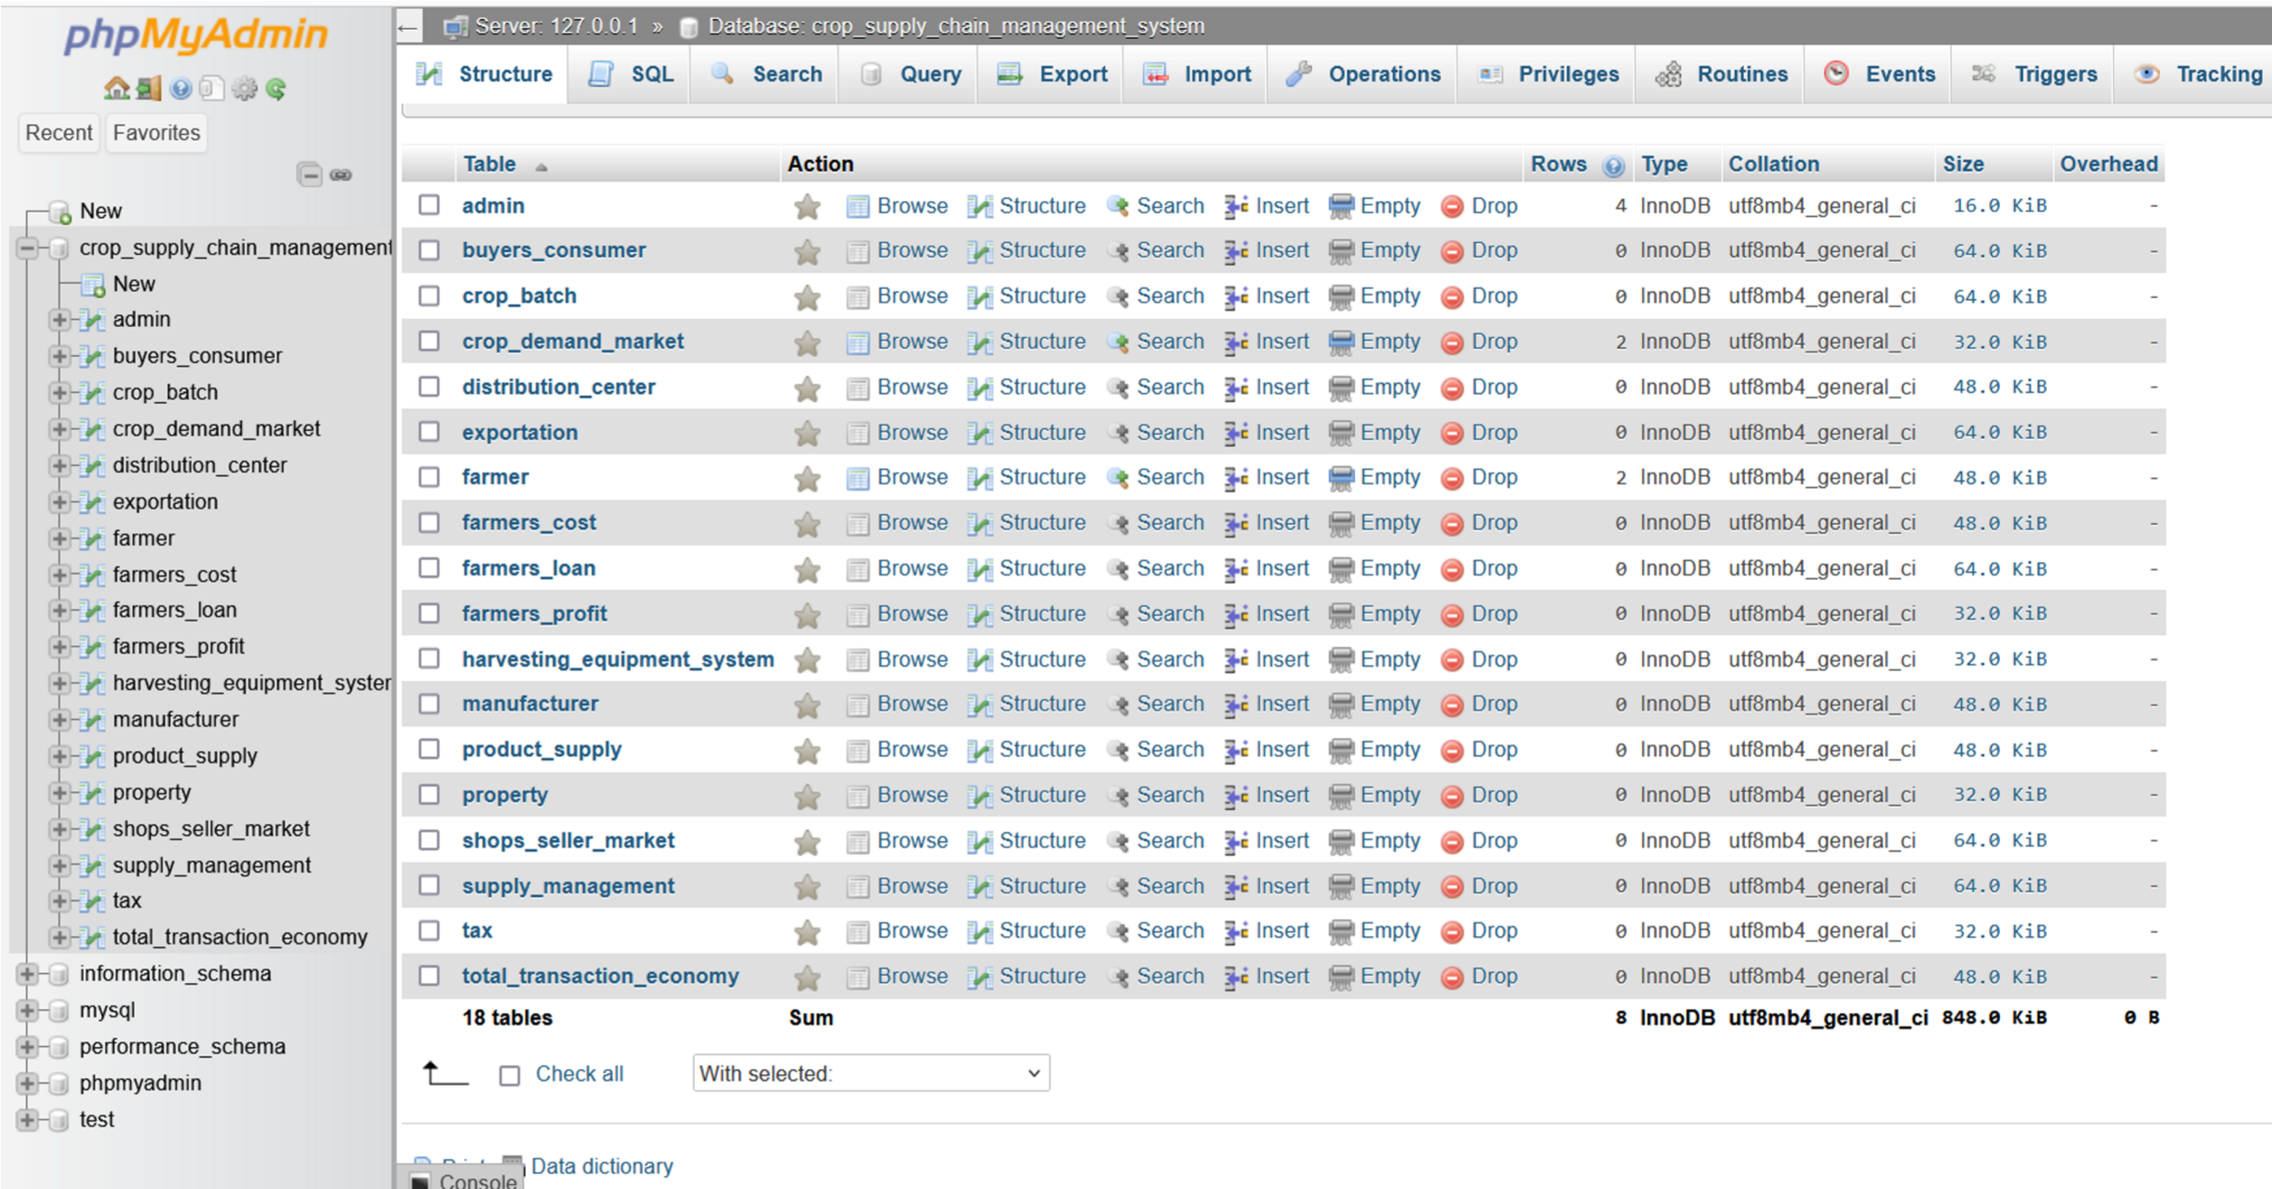);

**Table ScreenShot**

**All Tables of Database :**

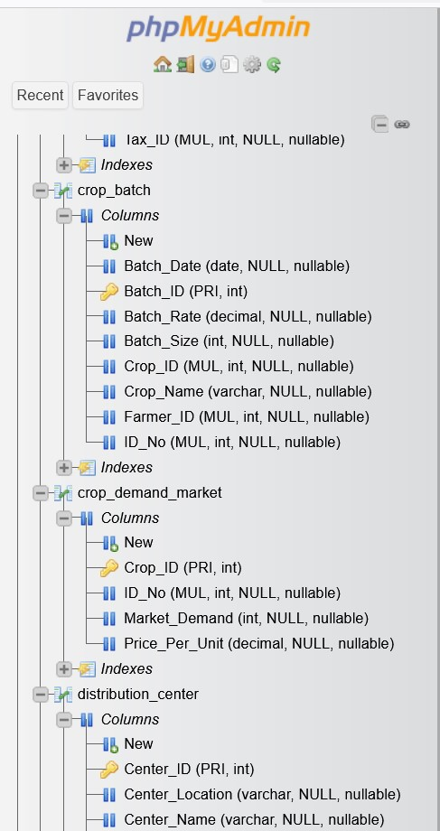

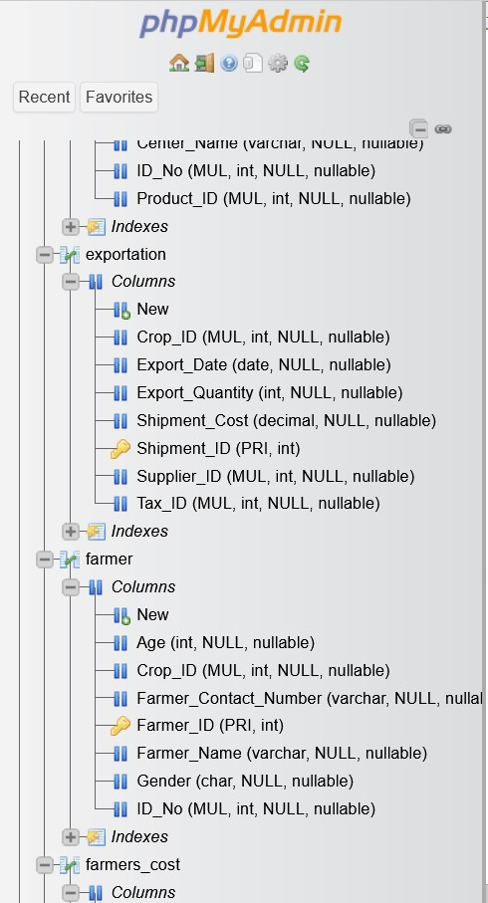

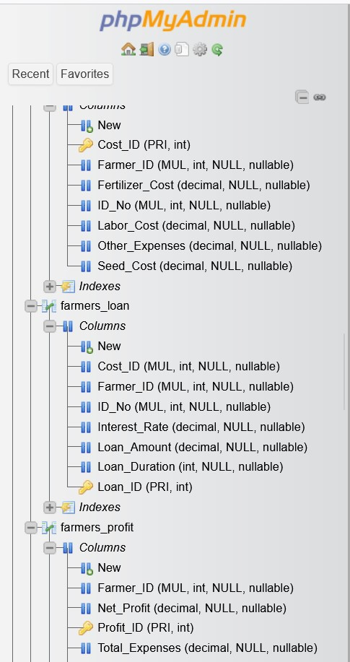

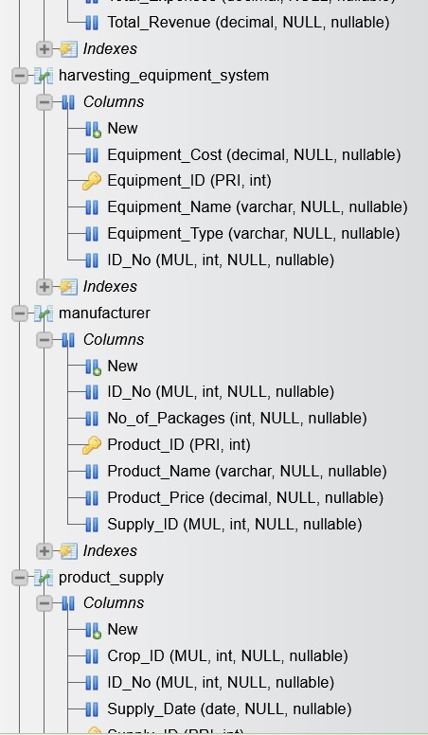

**Query:**

**1.Retrieve Farmers' Names and Contact Numbers:**

SELECT Farmer_Name, Farmer_Contact_Number FROM Farmer;

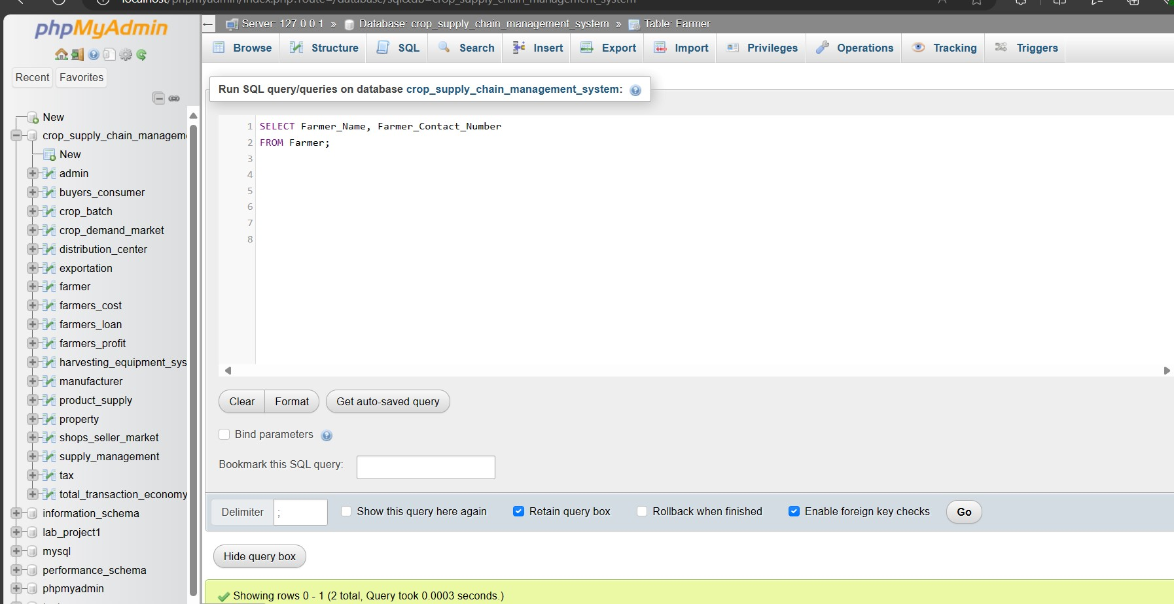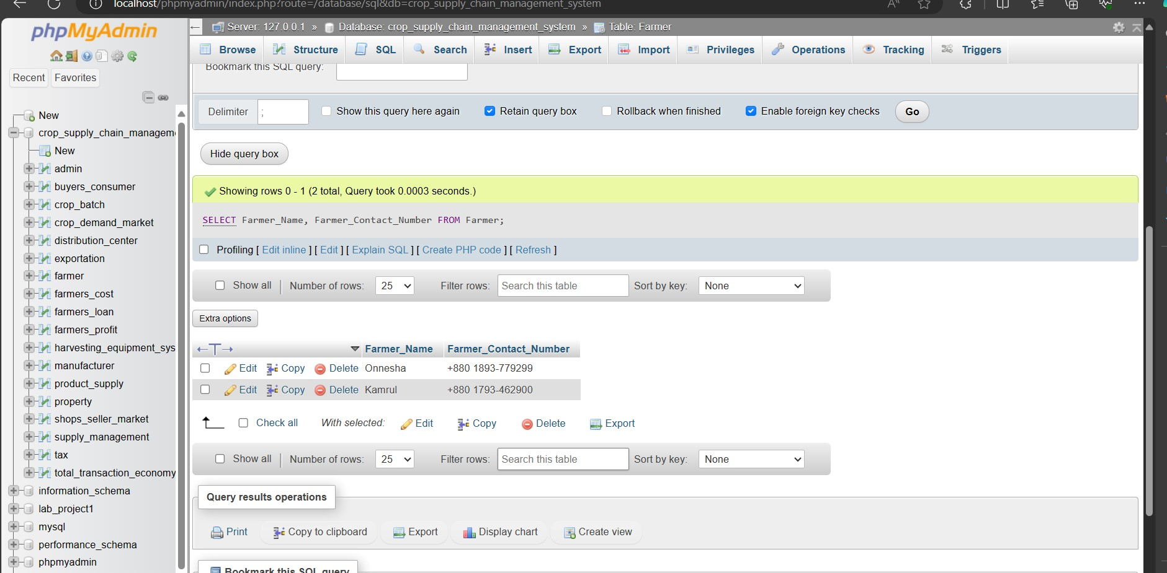

**2.Find the Total Supply Quantity of Each Product:**

SELECT Supply_ID, SUM(Supply_Quantity) AS Total_Supply_Quantity

FROM Product_Supply

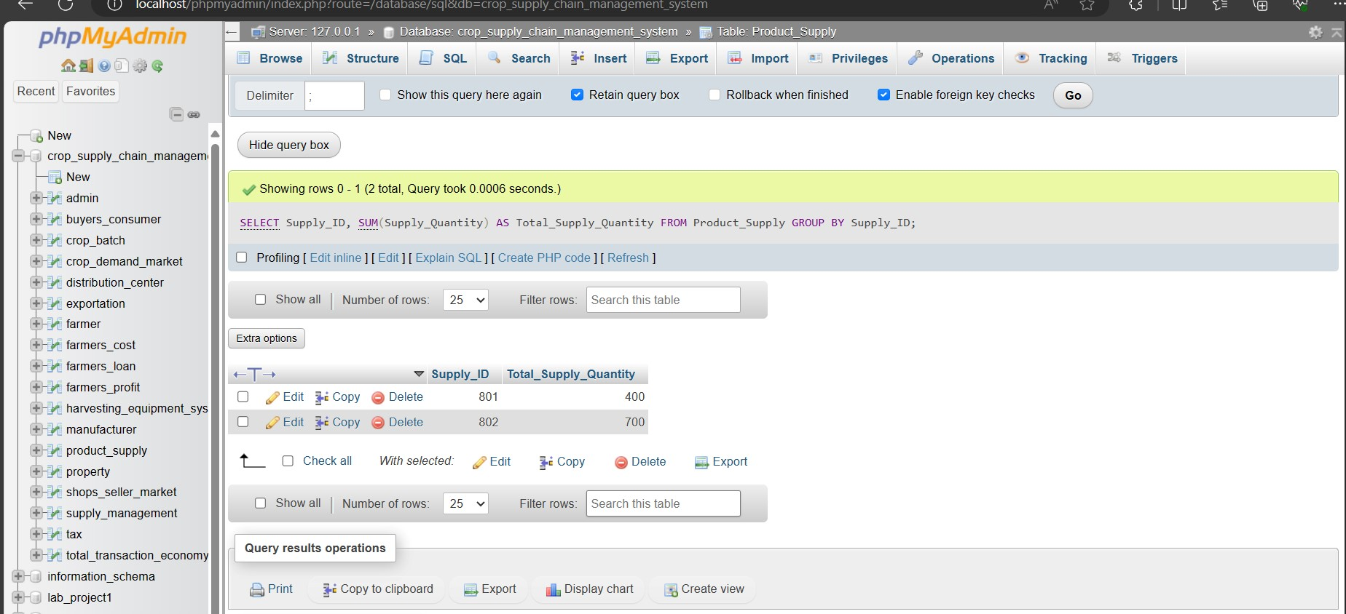

**3.Calculate Total Expenses for Each Farmer:**

SELECT Farmer_ID, SUM(Seed_Cost + Fertilizer_Cost + Labor_Cost + Other_Expenses) AS

Total_Expenses

FROM Farmers_Cost GROUP BY Farmer_ID;

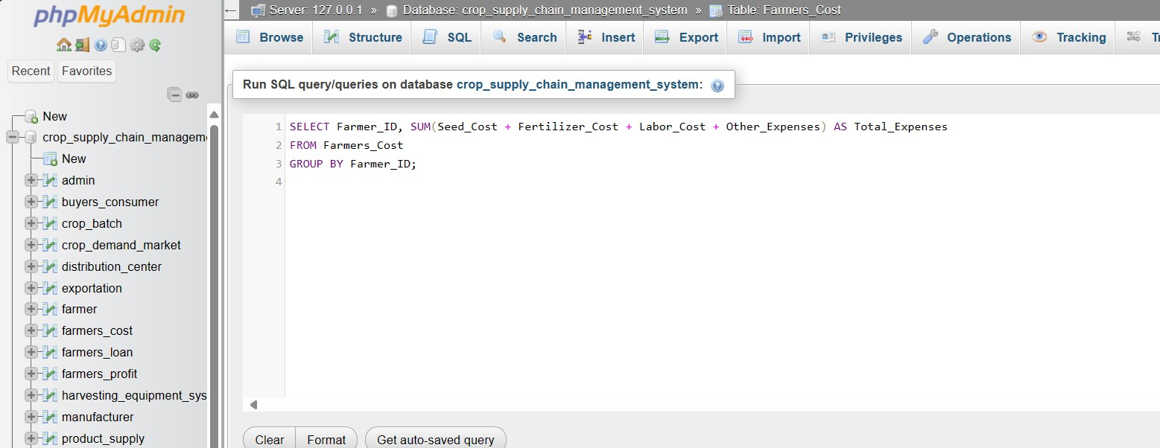

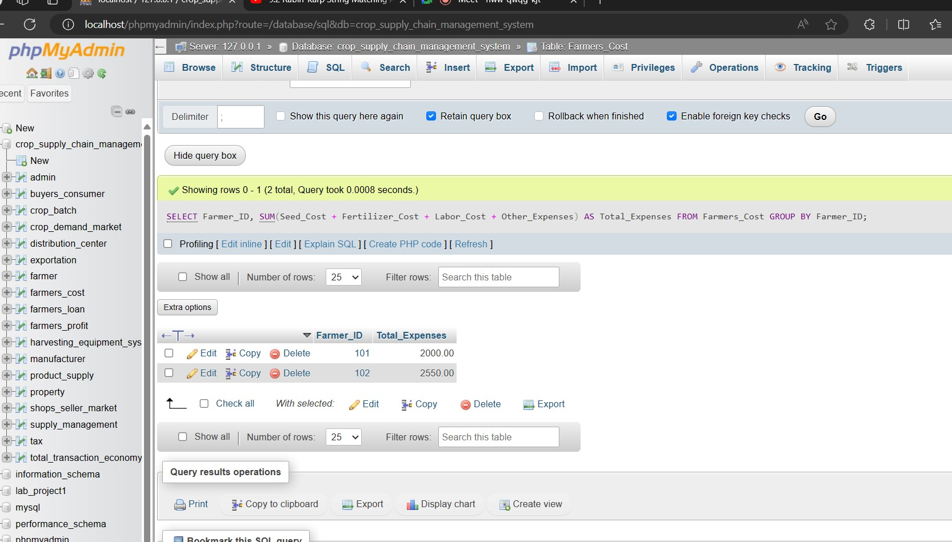

**4.List the Top 5 Farmers by Net Profit:**

SELECT Farmer_ID, Net_Profit

FROM Farmers_Profit

ORDER BY Net_Profit DESC

LIMIT 5;

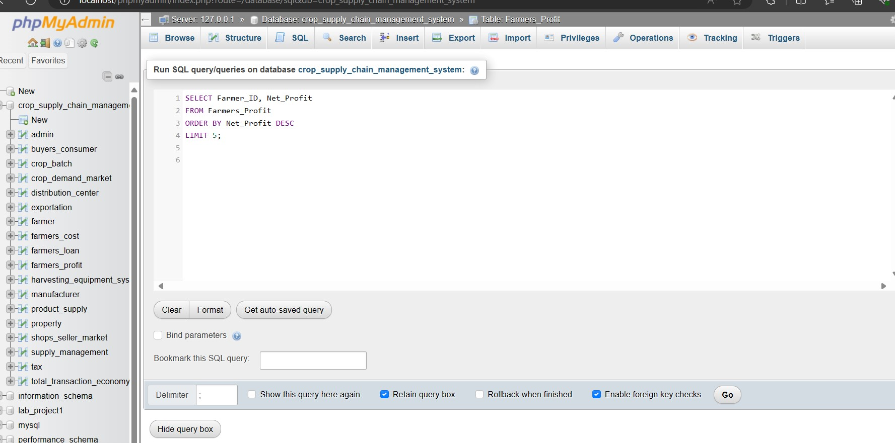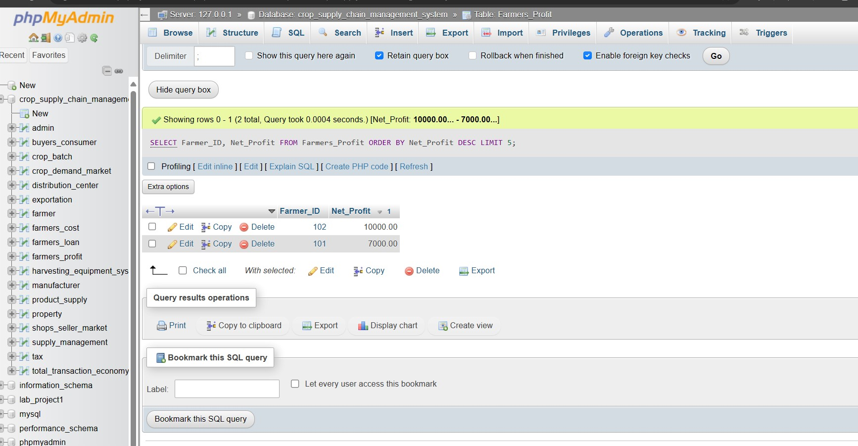

**5.Find the Average Price Per Unit of Each Crop:**

SELECT Crop_ID, AVG(Price_Per_Unit) AS Avg_Price_Per_Unit

FROM Crop_Demand_Market

GROUP BY Crop_ID;

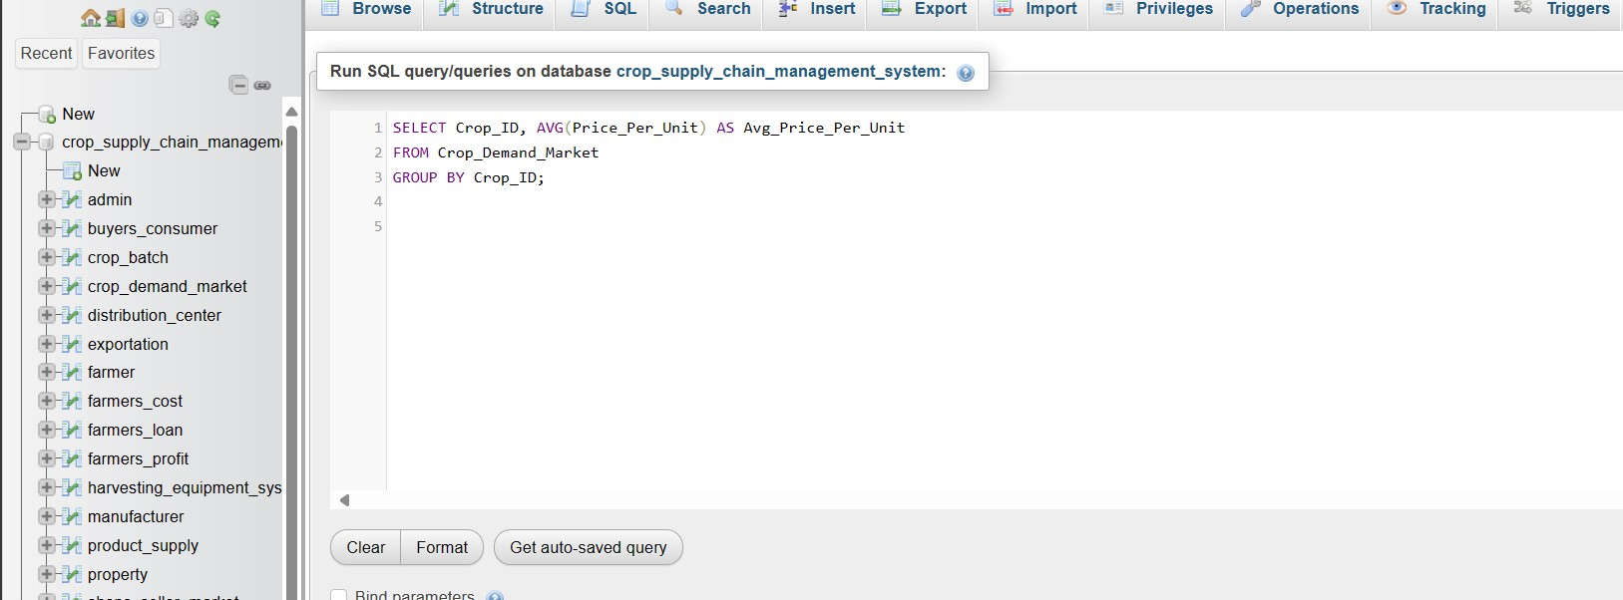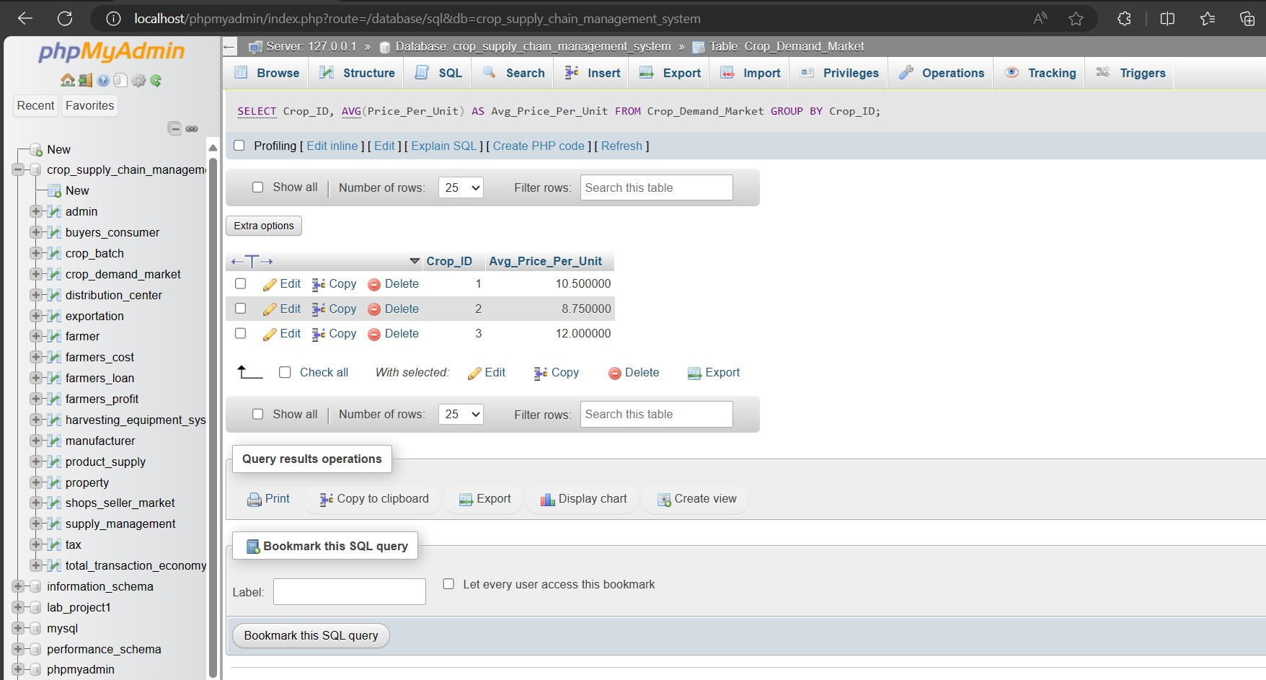

**6.Identify Farmers Who Took Loans with a Loan Amount Over**

**$20,000:**

SELECT Farmer_ID, Loan_Amount

FROM Farmers_Loan

WHERE Loan_Amount > 20000;

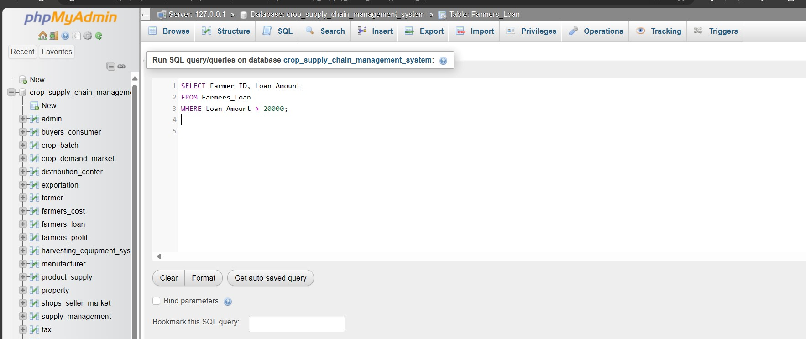

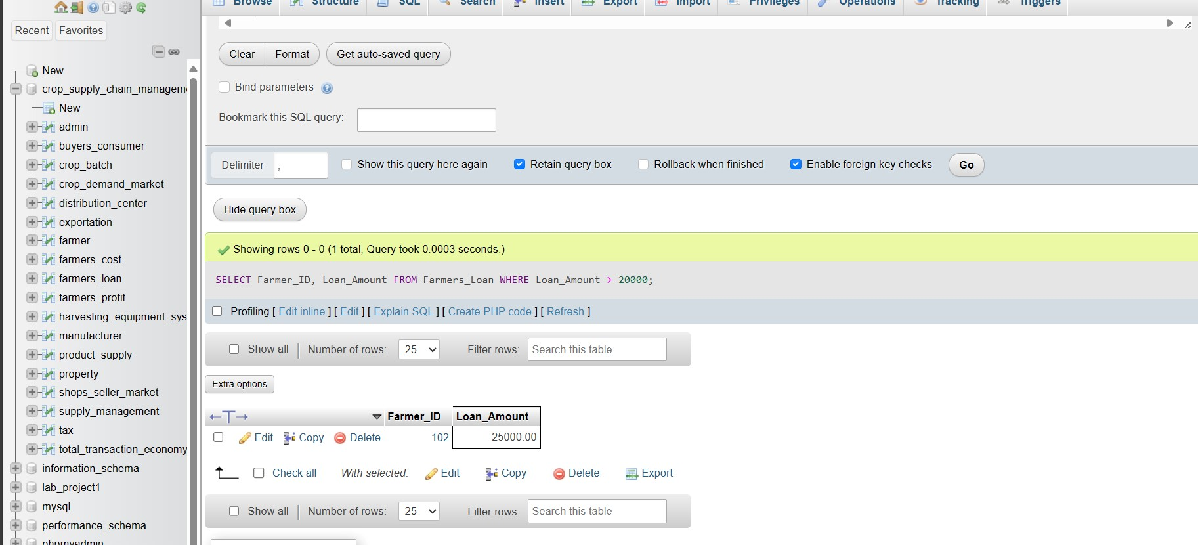

**7.Retrieve Crop Batches with a Batch Rate Over $10.00:**

SELECT Batch_ID, Crop_Name, Batch_Rate

FROM Crop_Batch

WHERE Batch_Rate > 10.00;

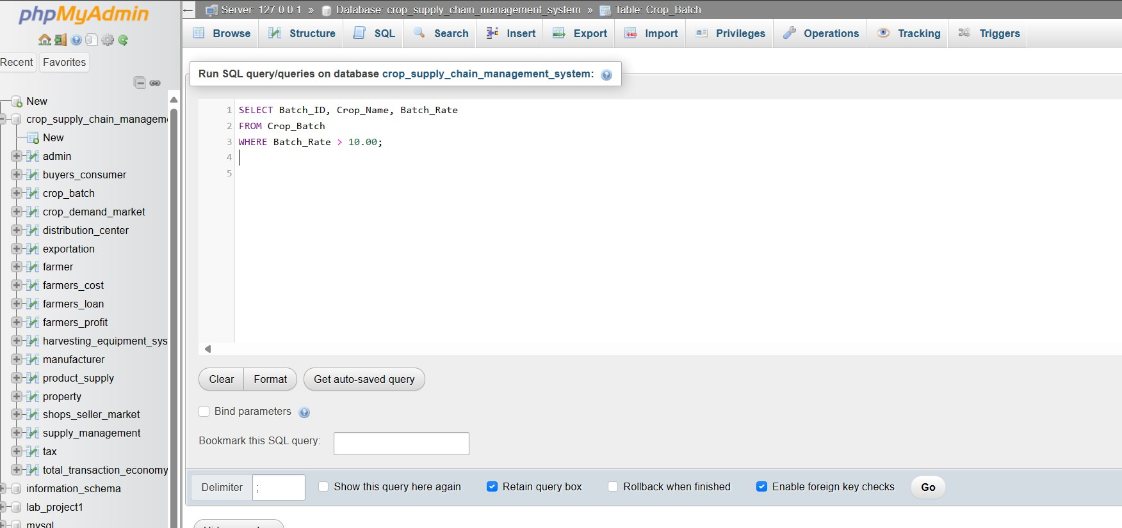

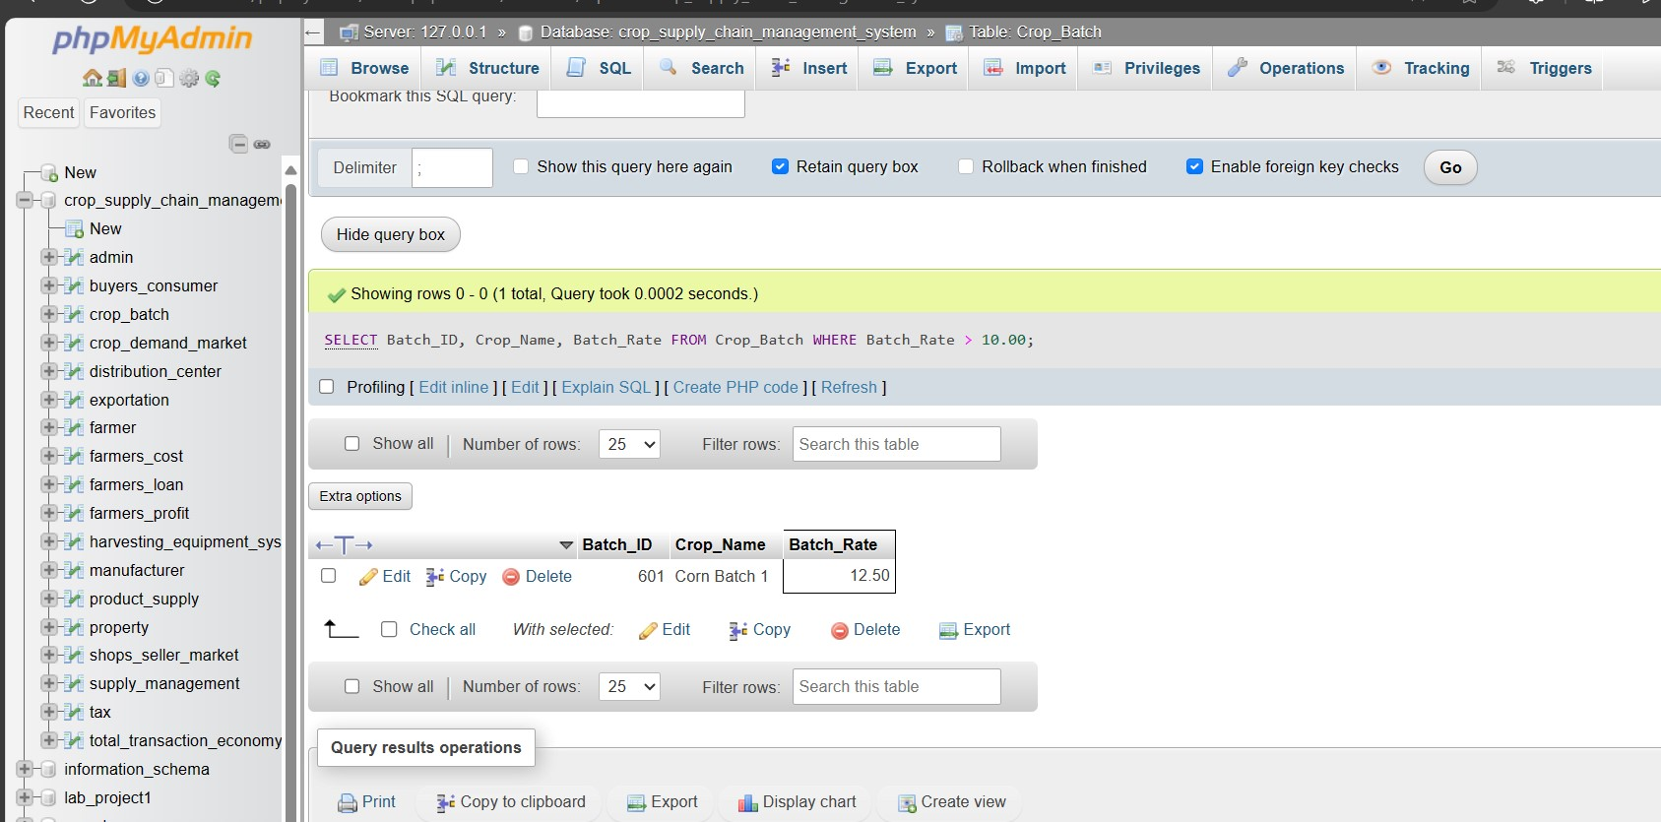

**8.List the Manufacturers with their Product Names and Prices:**

SELECT Manufacturer.Product_ID, Manufacturer.Product_Name, Manufacturer.Product_Price

FROM Manufacturer;

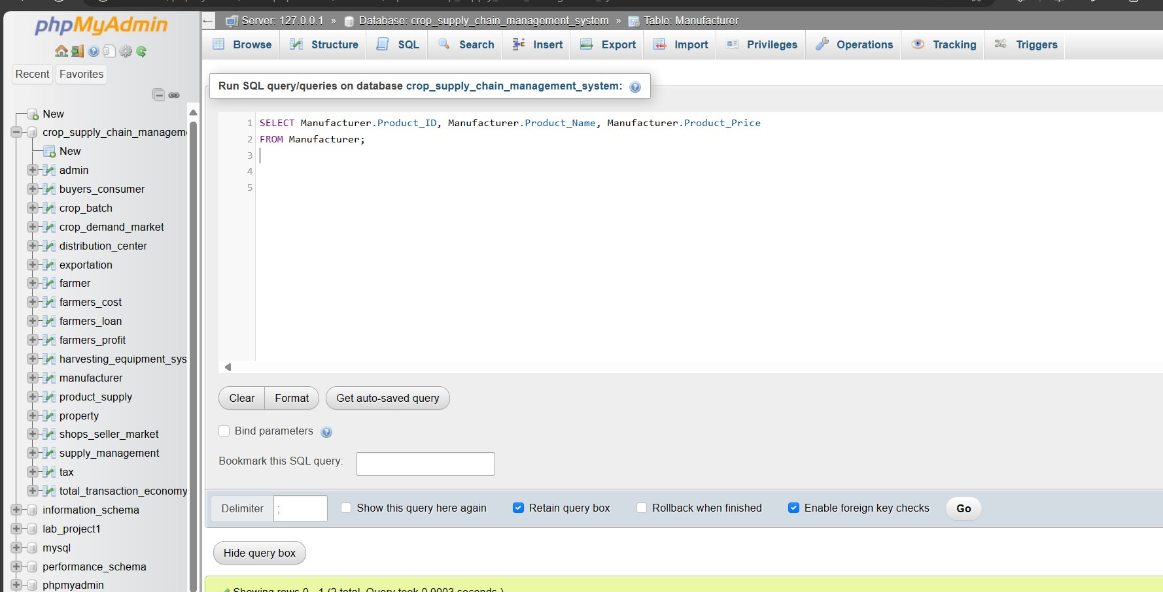

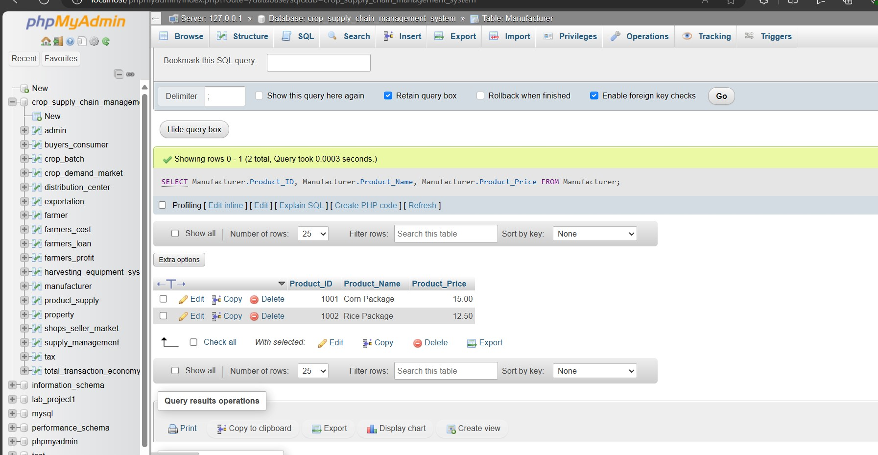

**9.Find the Total Transaction Value for Each Tax Type:**

SELECT Tax_Type, SUM(Total_Transaction_Value) AS Total_Value

FROM Tax

JOIN Total_Transaction_Economy ON Tax.Tax_ID = Total_Transaction_Economy.Tax_ID

GROUP BY Tax_Type;

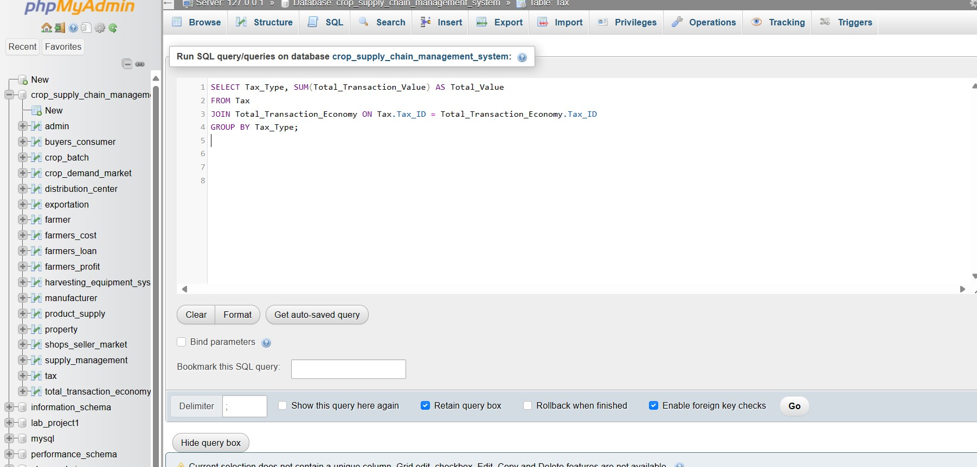

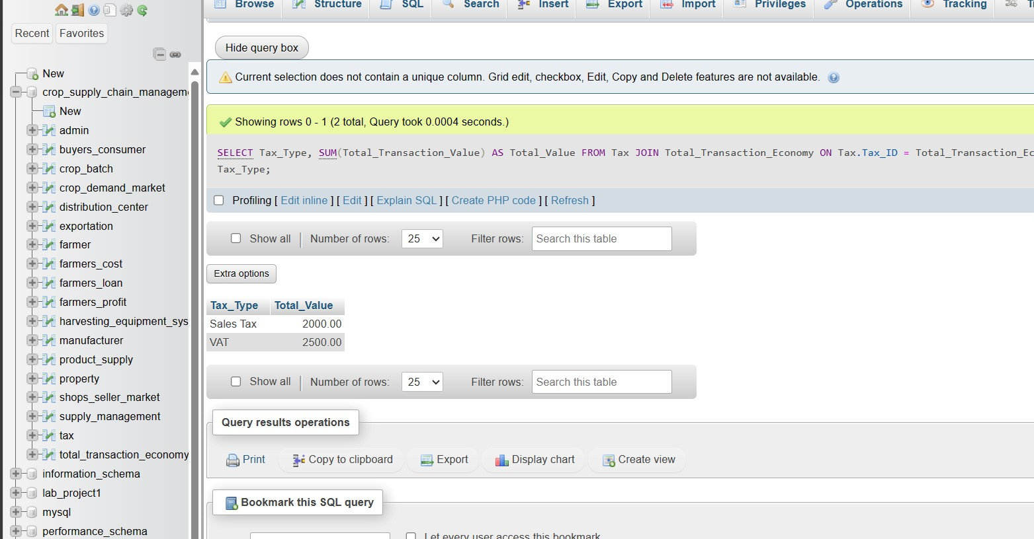

**10.Count the Number of Shops in Each Location:**

SELECT Shop_Location, COUNT(Shop_ID) AS Shop_Count

FROM Shops_Seller_Market

GROUP BY Shop_Location;

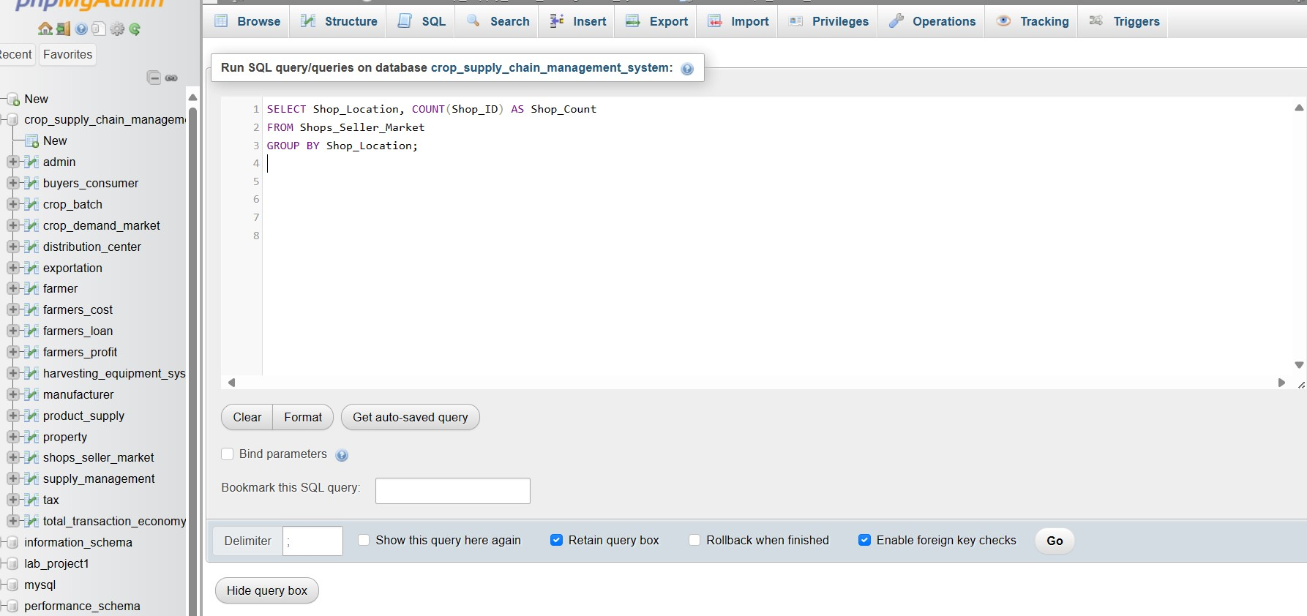

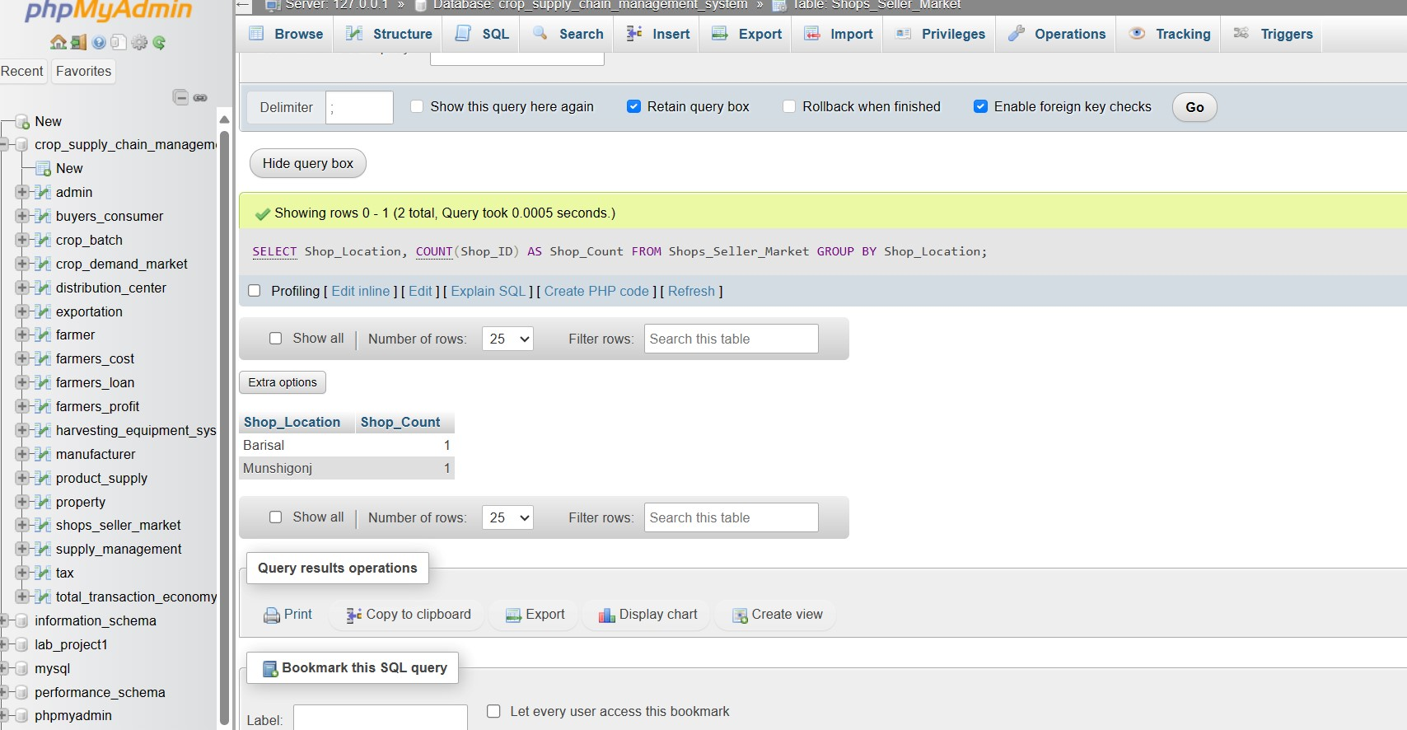

**11.Concat Operation:**

SELECT concat('ID_No', ' ', 'Email_Address')As new_information;

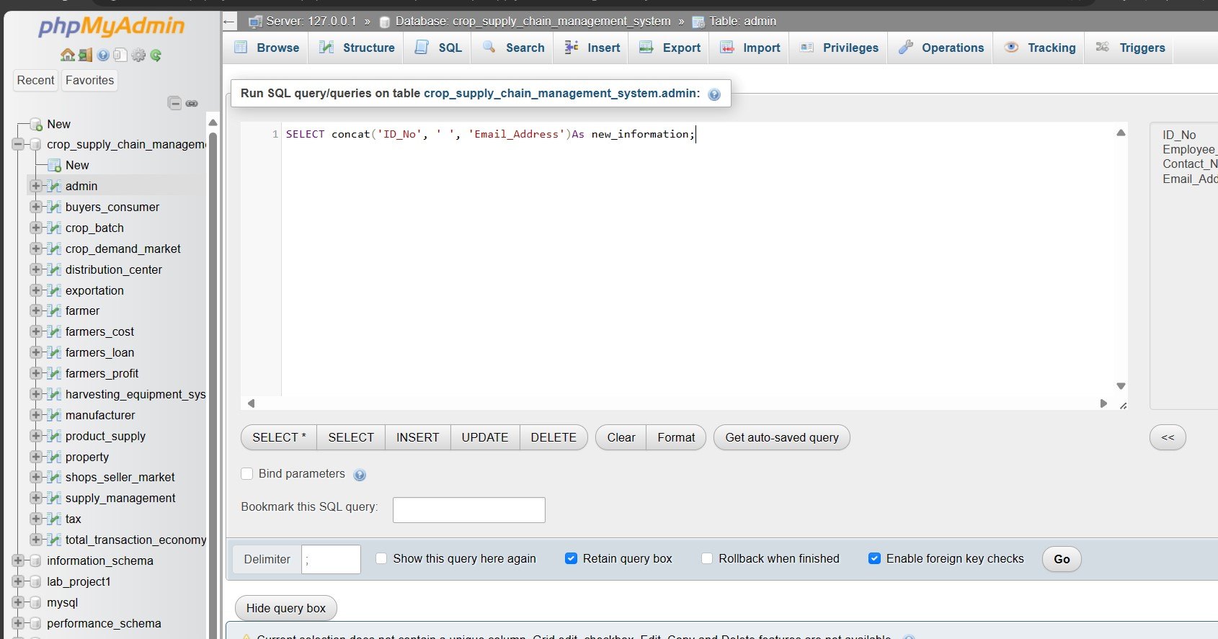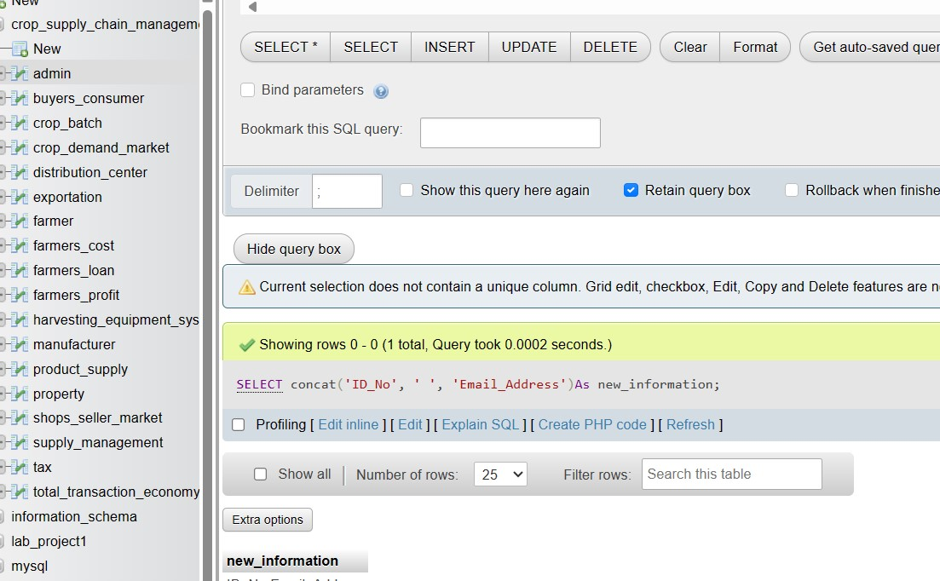

**Insert Data Into Tables:**

INSERT INTO Property (Property_ID, Farmer_ID, Property_Address, Property_Size, Property_Value, Crop_Type)

VALUES

(201,101, 'Khulna', 10.5, 10000.00, 'Corn'),

(202, 102, 'Cumilla', 8.0, 8000.00, 'Rice');

INSERT INTO Farmers_Cost (Cost_ID, ID_No, Farmer_ID, Seed_Cost, Fertilizer_Cost, Labor_Cost, Other_Expenses)

VALUES

(301, 43, 101, 500.00, 300.00, 1000.00, 200.00),

(302, 47, 102, 700.00, 400.00, 1200.00, 250.00);

INSERT INTO Harvesting_Equipment_System (Equipment_ID, ID_No, Equipment_Name, Equipment_Type, Equipment_Cost)

VALUES

(401, 43, 'Combine Harvester', 'Heavy Machinery', 50000.00),

(402, 50, 'Tractor', 'Heavy Machinery', 30000.00);

INSERT INTO Farmers_Loan (Loan_ID, Farmer_ID, Cost_ID, Loan_Amount, Interest_Rate, Loan_Duration, ID_No)

VALUES

(501, 101, 301, 20000.00, 5.5, 24, 47),

(502, 102, 302, 25000.00, 6.0, 36, 48);

INSERT INTO Crop_Demand_Market (Crop_ID, ID_No, Market_Demand, Price_Per_Unit)

VALUES

(1, 43, 500, 10.50), (2, 47, 800, 8.75),

(3, 48, 300, 12.00);

INSERT INTO Crop_Batch (Batch_ID, Crop_ID, Farmer_ID, ID_No, Crop_Name, Batch_Size, Batch_Rate, Batch_Date)

VALUES

(601,2, 101, 47, 'Corn Batch 1', 500, 12.50, '2024-04-20'),

(602, 3, 102, 48, 'Rice Batch 1', 800, 10.00, '2024-04-22');

INSERT INTO Farmers_Profit (Profit_ID, Farmer_ID, Total_Revenue, Total_Expenses,

Net_Profit)

VALUES

(701, 101, 15000.00, 8000.00, 7000.00),

(702, 102, 20000.00, 10000.00, 10000.00);

INSERT INTO Product_Supply (Supply_ID, Crop_ID, ID_No, Supply_Quantity, Supply_Date)

VALUES

(801, 1, 43, 400, '2024-04-25'),

(802, 2, 47, 700, '2024-04-26');

INSERT INTO Supply_Management (Supplier_ID, Supply_ID, Batch_ID, ID_No,

Supplier_Name, Management_Type)

VALUES

(901, 801, 601, 47, 'Farmers Supply Co.', 'Direct'),

(902, 802, 602, 48, 'Agro Distributors', 'Indirect');

INSERT INTO Farmer (Farmer_ID, ID_No, Crop_ID, Farmer_Name, Age, Gender,

Farmer_Contact_Number)

VALUES

(101, 48, 1, 'Onnesha', 35, 'female', '+880 1893-779299'),

(102, 50, 2, 'Kamrul', 28, 'male', '+880 1793-462900');

INSERT INTO Manufacturer (Product_ID, Supply_ID, ID_No, Product_Name, Product_Price,

No_of_Packages)

VALUES

(1001, 801, 50, 'Corn Package', 15.00, 500),

(1002, 802, 47, 'Rice Package', 12.50, 800);

INSERT INTO Distribution_Center (Center_ID, Product_ID, ID_No, Center_Name,

Center_Location)

VALUES

(2001, 1001, 43, 'AgroMart Distribution Center', 'Dhaka'),

(2002, 1002, 48, 'Farmers Supply Depot', 'Feni');

INSERT INTO Tax (Tax_ID, ID_No, Tax_Type, Tax_Rate)

VALUES

(3001, 47, 'Sales Tax', 8.0),

(3002, 48, 'VAT', 10.0);

INSERT INTO Shops_Seller_Market (Shop_ID, Product_ID, Tax_ID, DCenter_ID, Shop_Name, Shop_Location)

VALUES

(4001, 1001, 3001, 2001, 'AgroMart Outlet', 'Barisal'),

(4002, 1002, 3002, 2002, 'Farmers Market', 'Munshigonj');

INSERT INTO Exportation (Shipment_ID, Crop_ID, Tax_ID, Supplier_ID, Shipment_Cost, Export_Quantity, Export_Date)

VALUES

(5001, 1, 3001, 901, 5000.00, 200, '2024-04-27'),

(5002, 2, 3002, 902, 7500.00, 300, '2024-04-28');

INSERT INTO Buyers_Consumer (Buyers_ID, Product_ID, Tax_ID, Shop_ID, Buyers_Name, Buyers_Contact)

VALUES

(6001, 1001, 3001, 4001, 'Imtiaj', '+880 1903-069376'),

(6002, 1002, 3002, 4002, 'Maliha', '+880 1720-495548');

INSERT INTO Total_Transaction_Economy (Transaction_ID, Tax_ID, ID_No,

Total_Transaction_Value, Transaction_Date)

VALUES

(7001, 3001, 48, 2000.00, '2024-06-23'),

(7002, 3002, 50, 2500.00, '2024-04-24');

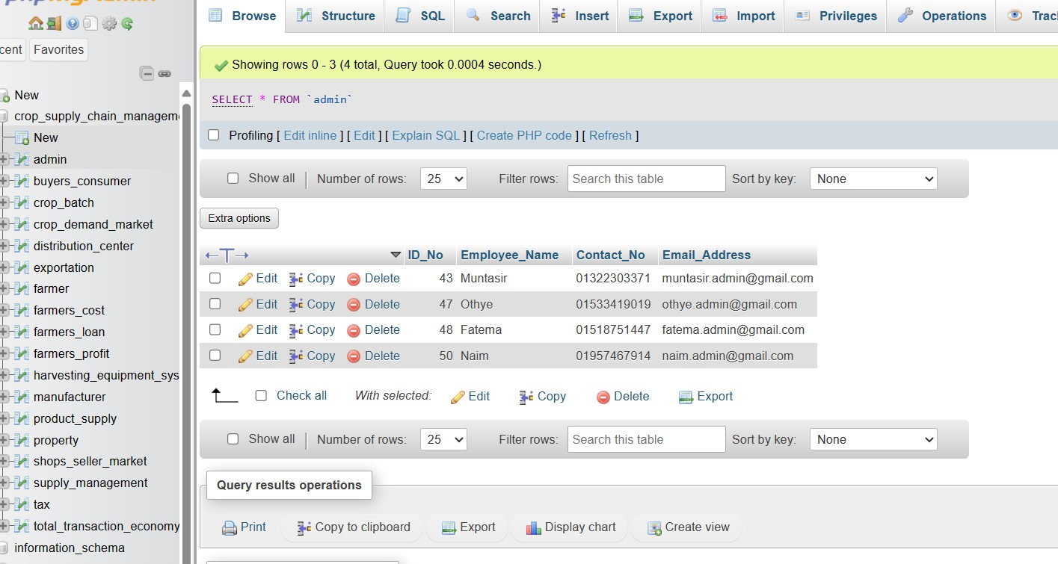

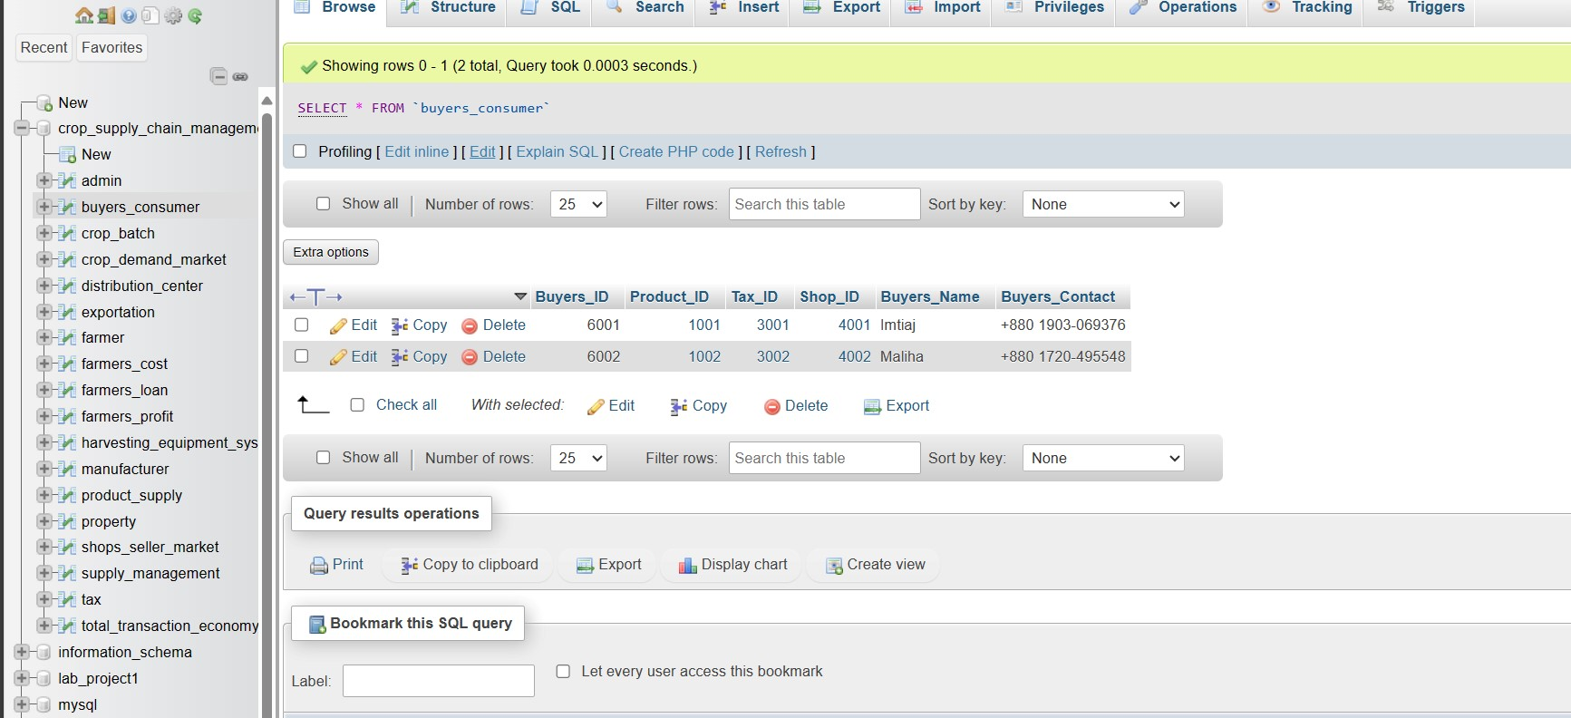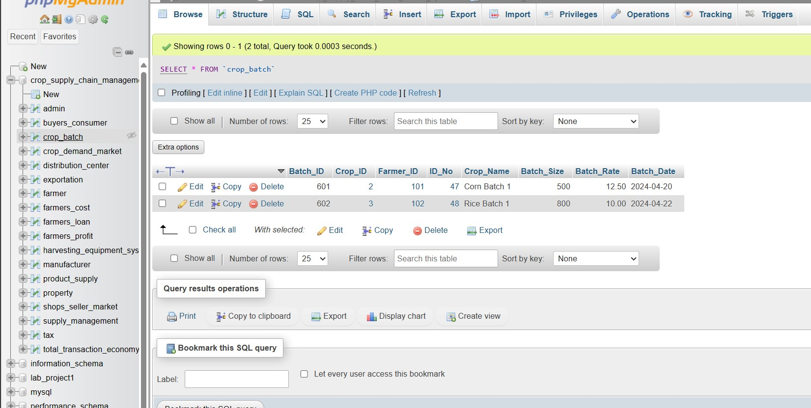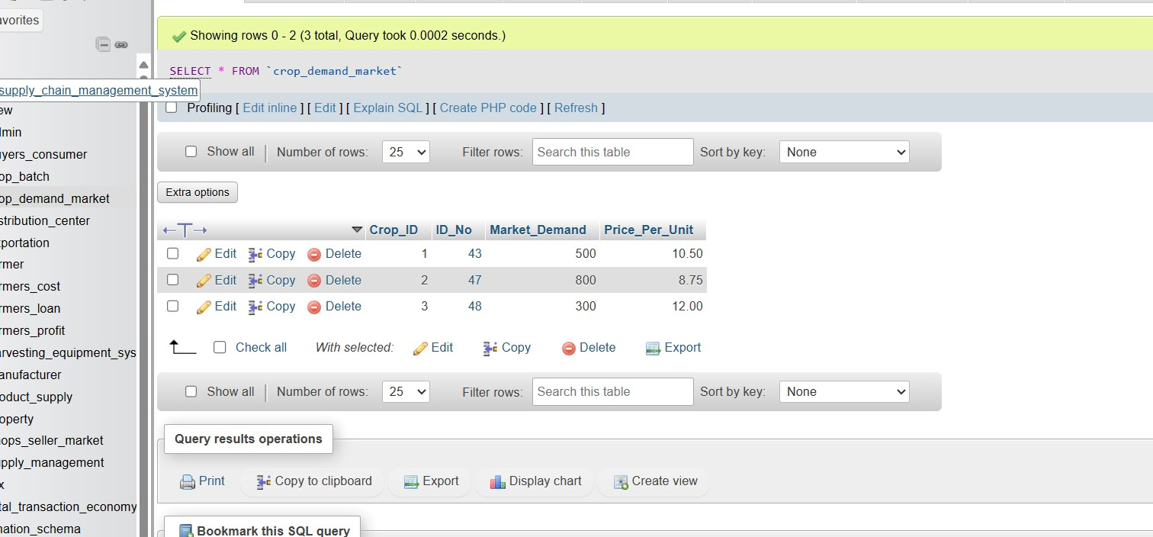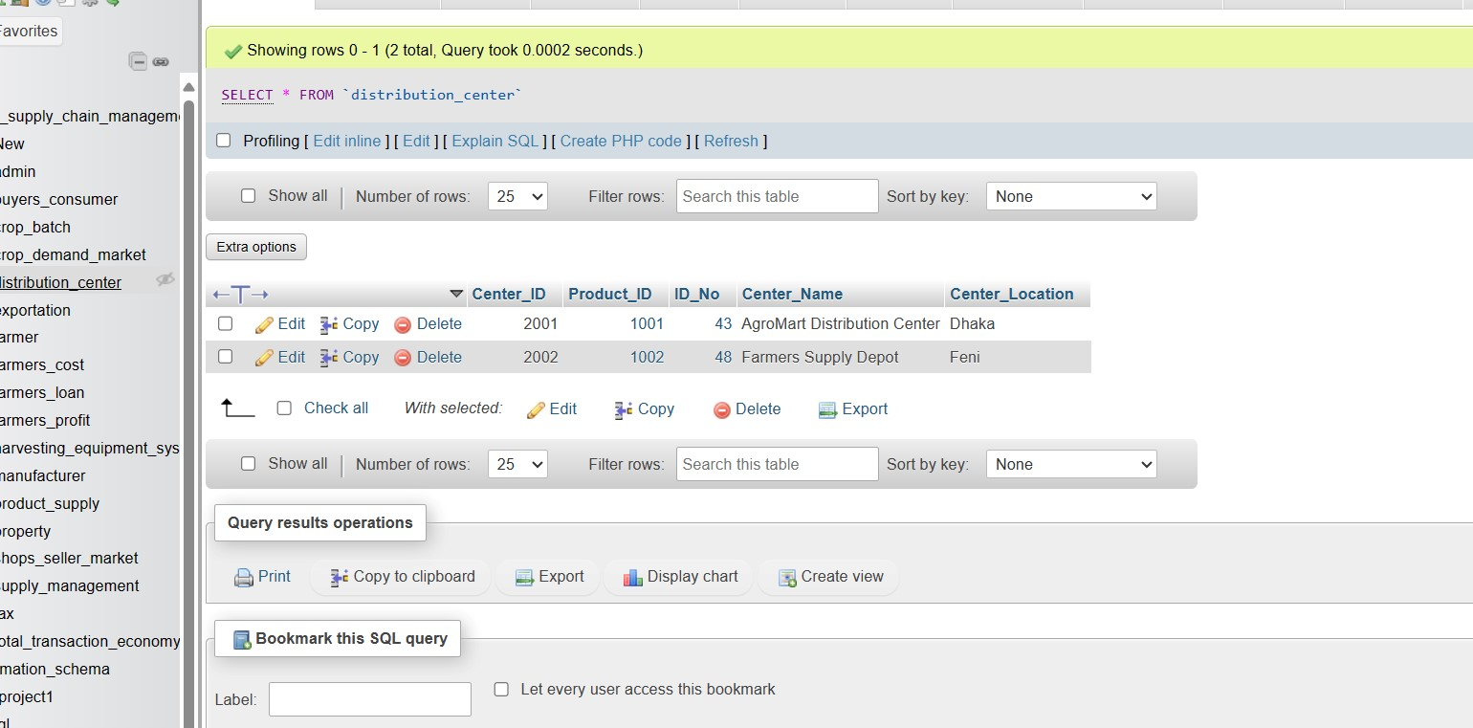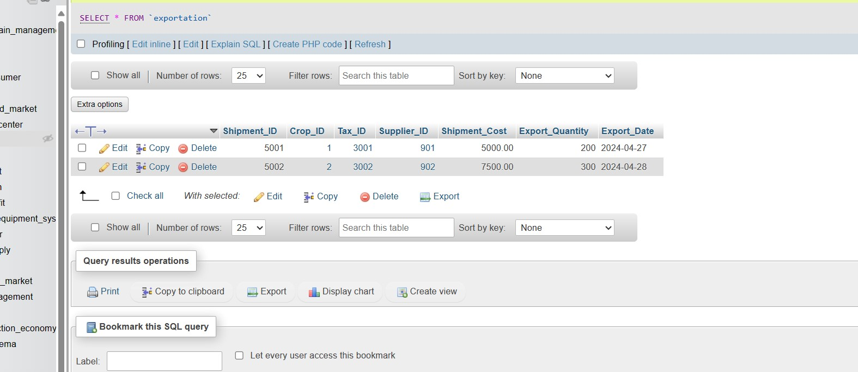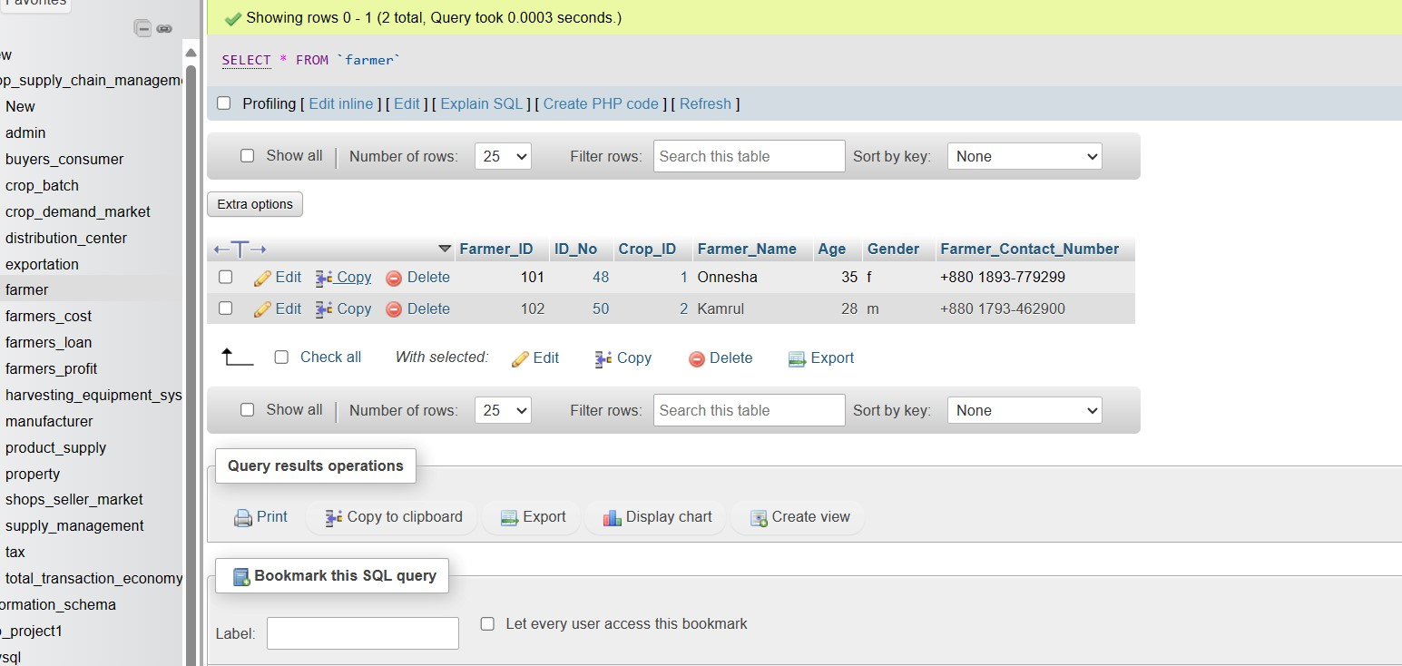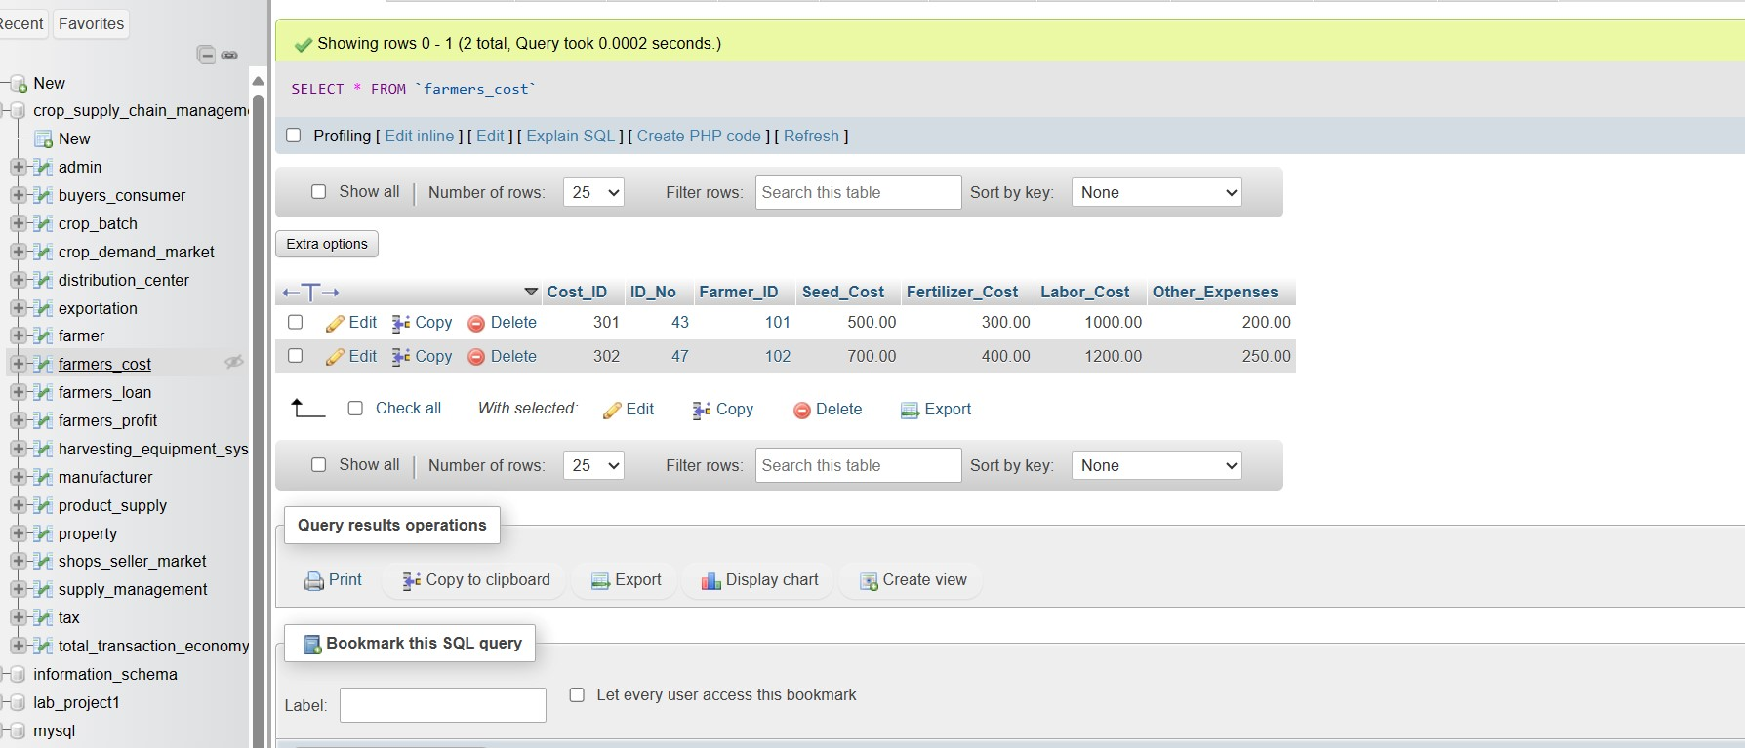

**Addressing Complex Engineering Problems (Ks , Ps & As)**

**Through This Project**

**What is CEP(Complex Engineering Program):**

A complex engineering problem is a challenge or issue within the field of engineering that is difficult to solve due to its intricate nature, involving multiple variables, constraints, and often requiring interdisciplinary approaches. These problems typically involve designing, analyzing, or optimizing systems, structures, or processes to meet specific requirements or objectives.

**Characteristics :**

CEP have some or all of the following characteristics:

1. Involve wide-ranging or conflicting technical, engineering, and other issues.
2. Have no obvious solution and require originality in analysis.
3. Involve infrequently encountered issues.
4. Are outside problems encompassed by standards and codes of practice for professional engineering .
5. Involve diverse groups of stakeholders with widely varying needs.
6. Have significant consequences in a range of contexts .
7. Cannot be resolved without in-depth engineering knowledge.

For applying this database in terms of solving Complex Engineering Problems the individuals should have proper Engineering knowledge. Because this database is constructed on the basis of Engineering knowledge and without proper Engineering knowledge one can not use or maintain this database accurately.They will be unable to understand the terms and the objectives of this database.The connections are being described below accordingly.

**Knowledge Profiles(Kp)**

|  |
| --- |
| **K1 – natural sciences** |
| **K2 – mathematics** |
| **K3 – engineering fundamentals** |
| **K4 – specialist knowledge** |
| **K5 – engineering design** |
| **K6 – engineering practice** |
| **K7 – comprehension** |
| **K8 – research literature** |

**Knowledge Profile (K1-K8):**

**Natural Sciences (K1):**

Understanding of agricultural sciences related to crop cultivation, including soil science, plant biology, and agricultural economics.

Knowledge of natural phenomena affecting crop production, such as weather patterns, pests, and diseases.

**Mathematics (K2):**

Utilization of mathematical concepts for database design, such as entity-relationship modeling and normalization techniques.

Application of mathematical principles for data analysis, such as calculating crop yields, profits, and market demand projections.

**Engineering Fundamentals (K3):**

Understanding the principles of database management systems (DBMS) and their applications in supply chain management.Knowledge of system architecture design, including components, interactions, and technology stack selection.

**Specialist Knowledge (K4):**

In-depth understanding of crop supply chain management processes, including seed selection, cultivation, distribution, and sales.Familiarity with database design principles tailored to the agricultural industry's specific requirements.

**Engineering Design (K5):**

Application of engineering design methodologies to develop the database system architecture, considering scalability, reliability, and security.

Incorporation of user interface design principles to create intuitive interfaces for different stakeholders interacting with the system. We constructed our database system by the knowledge of Entity Relations, ER-Diagram & Schema Diagram.

**Engineering Practice (K6):**

Practical implementation of the database system using appropriate development tools and methodologies.Integration of advanced technologies like blockchain and artificial intelligence to address challenges in crop supply chain management.

**Comprehension (K7):**

Ability to comprehend complex agricultural supply chain dynamics and stakeholders' roles within the system.Comprehension of database design principles and their implications on system performance, security & usability.

**Research Literature (K8):**

Review and analysis of existing literature and research studies related to crop supply chain management systems.Incorporation of insights from relevant studies to inform system design decisions and address challenges identified in the agricultural industry.

**Addressing Complex Engineering Problem (Ps) through this project:**

|  |  |
| --- | --- |
| **Attribute** | **P1 and some or all of P2 to P7:** |
| **Depth of knowledge required** | **P1: one or more of K3, K4, K5, K6 or K8** |
| **Range of conflicting**  **requirements** | **P2: wide-ranging or conflicting technical, engineering and other issues** |
| **Depth of analysis required** | **P3: no obvious solution** |
| **Familiarity of issues** | **P4: Involve infrequently encountered issues** |
| **Extent of applicable codes** | **P5: outside problems encompassed by standards and codes of practice .** |
| **Extent of stake-holder involvement and conflicting requirements** | **P6: diverse groups of stakeholders with widely varying needs** |
| **Interdependence** | **P7: many component parts or sub-problems** |

**We explore how a few Ps are addressed**

**Identify Depth of Knowledge (P1):**

You will need a deep understanding of engineering principles (K3), database design (K4), software development (K5), data management (K6), and potentially relevant technologies like blockchain or AI (K8).

**Assess Range of Conflicting Requirements (P2):**

You'll encounter conflicting technical requirements such as scalability vs. performance, security vs. usability, and reliability vs. cost-effectiveness.

**Analyze Depth of Analysis Required (P3):**

There might not be obvious solutions to some challenges you encounter, requiring in-depth analysis and innovative problem-solving approaches.

**Consider Familiarity of Issues (P4):**

The problems you face may involve infrequently encountered issues in the context of crop supply chain management and database systems.

**Evaluate Extent of Applicable Codes (P5):**

Your project may extend beyond the boundaries of existing standards and codes of practice, requiring novel solutions and approaches.

**Assess Stakeholder Involvement and Conflicting Requirements (P6):** You'll likely deal with diverse groups of stakeholders including farmers, distributors, retailers, and consumers, each with their own unique needs and requirements. Balancing these conflicting requirements will be crucial.

**Consider Interdependence (P7):**

The database system will have many component parts or sub-problems that are interdependent, such as data management, user interfaces,security measures, and integration with existing systems.

**To address these complexities, you'll need to:**

**1.**Conduct thorough research to understand the domain of crop supply chain management, database systems, and relevant technologies.

**2.**Employ interdisciplinary approaches, combining knowledge from engineering, agriculture, and information technology.

**3.**Engage stakeholders throughout the development process to ensure their needs are understood and addressed.

**4.**Utilize robust problem-solving methodologies to tackle challenges as they arise.

**5.**Continuously iterate and refine the system based on feedback and evolving requirements.

By following these steps and applying complex problem-solving techniques, we can develop a comprehensive and effective database system for managing the supply chain of crops.

**Addressing Complex Activities (As) through this project**

|  |  |
| --- | --- |
| **Attribute** | **Some or all of the following** |
| **Range of resources** | **A1: use of diverse resources**  **(include**  **people, money, equipment,**  **materials,**  **information and technologies)** |
| **Level of interaction** | **A2: resolution of significant problems arising from interactions between wide ranging or conflicting technical, engineering or other issues** |
| **Innovation** | **A3: creative use of engineering principles and research based knowledge in novel ways** |
| **Consequences for society and the environment** | **A4: consequences in a range of contexts, characterized by difficulty of prediction and**  **mitigation** |
| **Familiarity** | **A5: Can extend beyond previous experiences by applying**  **principles based approaches** |

**We explore how a few As are addressed**

A1: The project needs to engage diverse resources including people, money, information and technologies.

A2: A good level of interaction is needed among the Farmers, the

Agricultural Professionals and the participants.

A5: The project deals with a new area for computer science and engineering graduates.

By adhering to these steps, we can ensure that our project meets the criteria outlined in the Washington Accord, demonstrating the application of engineering principles in a complex and innovative manner while addressing societal and environmental implications.

# THE END